Online Conversation

A Learning Activity for 3-5

Overview
Through Social Media apps and video games, communicating with friends has never been easier! With this ease of access, however, also comes issues of authenticity, cyber safety, and honesty. In this inquiry-based activity, students will be encouraged to identify safe means of communication through the most current avenues readily available at their fingertips.

What You’ll Need
- Book - #Goldiocks – A Hashtag Cautionary Tale by: Jeanne Willis and Tony Ross  (For an online copy of the book, visit: https://www.youtube.com/watch?v=HMmgUFdaUjM)  - Tape | - Social Media App & Video Game Posters & Charts (1 printed copy per classroom)  - Pencils  - Post-It Notes (1 per student)

Instructions
- DISCUSSION: Ask the question: How is talking online with friends different than talking in person? (Are there different phrases, modes, pressure to respond, etc.?) Allow students to share their thoughts. Discuss: Why is it different? Should it be?

- APPS ALL AROUND: Tape up the Social Media Apps & Video Game posters (see below) around the classroom. Set a copy of the Charts with a pencil by each poster. Divide students into groups of 3-4 and have them rotate to each poster and write down their thoughts about communicating online. Some students may or may not use certain apps or games and have them write that on the chart. Ask students to rotate every 4-5 minutes until they have reached all 6.

- DISCUSSION: Quickly read over what students wrote at each Poster and then ask: Were there any apps or video games that you feel are safer to use than others? Are there some that you feel you can be more yourself? Which app or video game do you feel you can talk online with safety and honesty the most? (Poll the class)

- READ ALOUD – #Goldilocks – A Hashtag Cautionary Tale: Before reading, ask students if they use hashtags and what do they mean. After reading, discuss, “What lesson can we learn from Goldilocks? Have you ever posted something just for reaction? Have you ever posted something that you wish you could take back?”

- REFLECTION & NEXT STEPS: Give students each a Post-It Note and have them write down 1-2 things that would like to change about their online conversation. Collect those and read them anonymously as a group. With the notes in mind, co-construct a Top 5 List of Tips for Online Conversation (ask parents permission, never be alone, don’t type when angry, ask permission to post first, never give away personal information, set boundaries with time used, etc.) and post in the room near classroom devices as a reminder.

- CAREER CONNECTIONS: Discuss: “Do you think there might be a new, better app or video game developed in the future so that we can safely and authentically communicate? Check out Let’s Nuture (App Developer Company in Fredericton, NB) and to see what they do with an APP idea - https://www.letsnurture.ca/mobile-app-development-company-fredericton-new-brunswick.html Feel free to also check out the latest video games designed by Gogii Games in Moncton, NB at https://www.gogiigames.com/about. APP and video game development is here in New Brunswick and the possibilities have just scratched the surface!

- SHARE: Feel free to send photos of your class completing this learning activity to us via Twitter @NBCOE.

Possible Extensions
- Have students create a poster highlighting the Top 5 Tips for Online Conversation (have students use a variety of media: PowerPoint, Canva, Microsoft Word, Scratch, or even paper)
- Have students create an idea for an APP or video game and send an email/letter to one of our New Brunswick companies for feedback

Additional Read Aloud Suggestions
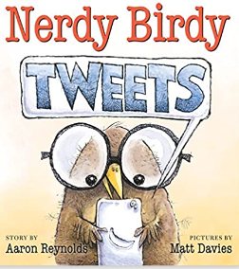 |  | 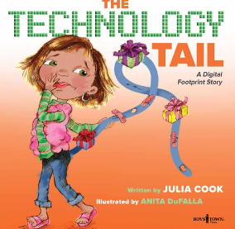
Nerdy Birdy Tweets  By: Aaron Reynolds  Illustrated by: Matt Davies | The Fabulous Friend Machine  By: Nick Bland | The Technology Tail  By: Julia Cook  Illustrated by: Anita DuFalla
Curricular Outcomes
Personal Wellness | Relationships – GCO 3: Students will apply the knowledge, skills, and attitudes necessary to establish and maintain healthy relationships  Grade 3 - 3.2 identify strategies to build and enhance friendships; 3.4 explore strategies to resolve  conflict.  Grade 4 - 3.2 identify the importance of communication to build and maintain friendships; 3.4 apply strategies to resolve conflict.  Grade 5 - 3.2 describe empathic responses and their impact on interpersonal relationships; 3.4 describe strategies to deal with conflict across a variety of interpersonal relationships.
Literacy | GCO 1: Students will speak and listen to explore, extend, clarify, and reflect on their  thoughts, ideas, feelings, and experiences.  GCO 2: Students will be able to communicate information and ideas effectively and  clearly, and to respond personally and critically.  GCO 3: Students will be expected to select, read, and view with understanding a range of  literature, information, media, and visual texts  GCO 6: Students will be expected to respond personally to a range of texts  GCO 8: Students will be expected to use writing and other forms of representation to explore, clarify, and reflect on their thoughts, feelings, experiences, and learnings; and to use their imaginations.

Global Competencies
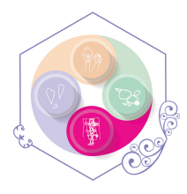 | 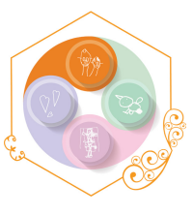 | 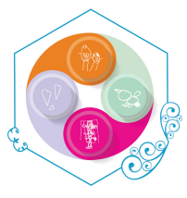 | 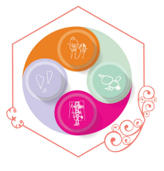 | 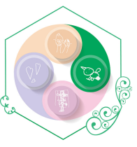
Collaboration | Communication | Critical Thinking & Problem-Solving | Innovation, Creativity & Entrepreneurship | Fostering and Teaching Self-Awareness and Self-Management

Social Media App #1

Social Media App #2

Social Media App #3

Social Media App #4

Video Games #5
Individual or Multi-Player

Video Games #6
Battle Royales

Social Media App #1
Tik Tok
How are people identified? (Username, email address, character) | How do people communicate? (Text, messaging, photo, comments) | Is there specialized vocabulary?  (Words, phrases, abbreviations, terms) | List things that you need to know to use it safely and authentically:
Social Media App #2
Snapchat
How are people identified? (Username, email address, character) | How do people communicate? (Text, messaging, photo, comments) | Is there specialized vocabulary?  (Words, phrases, abbreviations, terms) | List things that you need to know to use it safely and authentically:
Social Media App #3
Messenger Kids, Messenger, Facebook
How are people identified? (Username, email address, character) | How do people communicate? (Text, messaging, photo, comments) | Is there specialized vocabulary?  (Words, phrases, abbreviations, terms) | List things that you need to know to use it safely and authentically:
Social Media App #4
YouTube, YouTube Kids
How are people identified? (Username, email address, character) | How do people communicate? (Text, messaging, photo, comments) | Is there specialized vocabulary?  (Words, phrases, abbreviations, terms) | List things that you need to know to use it safely and authentically:
Video Games #5
Individual or Multi-player
How are people identified? (Username, email address, character) | How do people communicate? (Text, messaging, photo, comments) | Is there specialized vocabulary?  (Words, phrases, abbreviations, terms) | List things that you need to know to use it safely and authentically:
Video Games #6
Battle Royales
How are people identified? (Username, email address, character) | How do people communicate? (Text, messaging, photo, comments) | Is there specialized vocabulary?  (Words, phrases, abbreviations, terms) | List things that you need to know to use it safely and authentically:

