Geothermal Challenge Activity Guide

Background
Geothermal energy has been used as an energy source to heat and cool buildings for several decades now. Technically, GeoExchange is the correct term for this method of using the earth or water to heat and cool your home, but it’s been known by many names in the past (in addition to GeoExchange and GeoThermal) including: ground water source, ground water assisted, water to water, ground source heating etc. GeoExchange (aka Geothermal) Heating and Cooling | Lockhart Industries

Objective
Students will design a model of a geothermal exchange mechanism to either raise or lower the temperature of their solution.
The success of the model will be determined by the difference in temperature between the two containers.

What You’ll need
- 3 Large containers
- 25’ Aquarium tubing
- 16” Aquarium tubing
- 1 Large pipette
- 2 Thermometers
- 1 Measuring cup
- Water (warm or cold depending on objective)
- Gel packs or ice or acrylamide copolymer gel
- Towels

Challenge #1
Students must move 500 mL of water from container 1 to container 2 without pouring the water between the containers.
- Provide students with two containers, 16” aquarium tubing, large pipette and water.
- Place 500 mL of water into one container and ask students to use the materials provided to move the water from on container to the other without pouring the water. Students may need a hint to place the containers at different heights and use the pipette and tubing to form a siphon system.
- Once the water is moving, challenge students to find a way to increase the rate of flow.
- Debrief Challenge #1 - What worked well? What didn’t? How could the rate of flow be increased? Answers may include more tubing, larger tubing, increasing the height difference between the two containers.
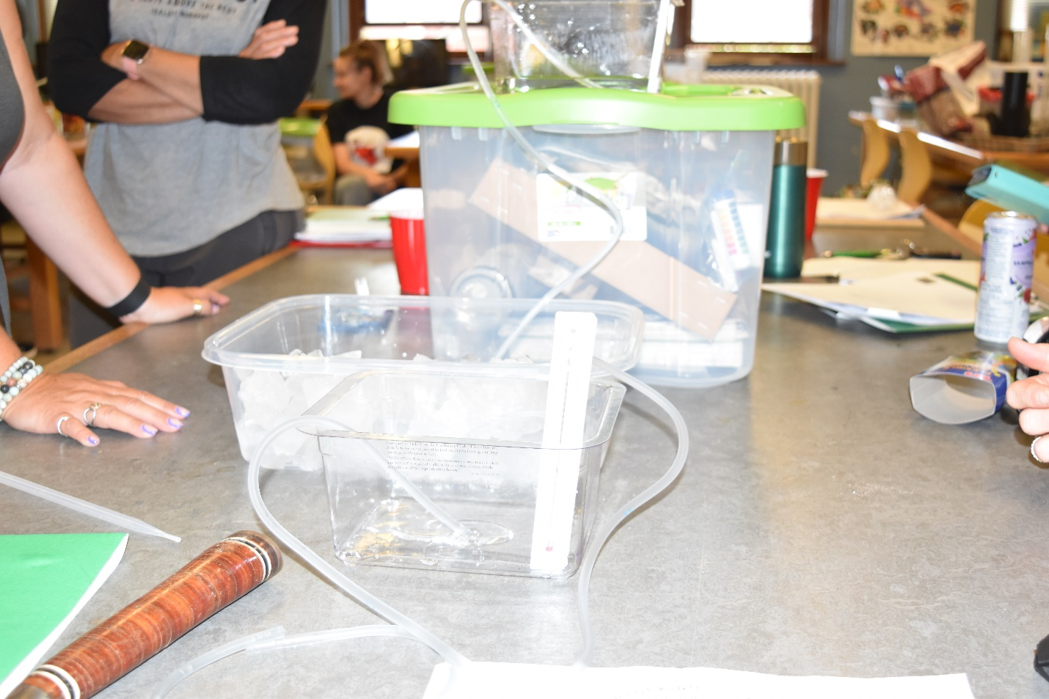

Challenge #2
Students must change the temperature of the water while moving it from container 1 to container 2 without pouring the water from the containers. The goal is to create the greatest change in temperature.

- Provide students with three containers, 25” aquarium tubing, large pipette and water. It is recommended that one container be larger and flat to mimic the ground.
- Prepare students by viewing a background video on Geothermal energy.
- Challenge the students to design a geothermal exchange system that will either raise or lower the temperature of the solution while moving from container 1 through the “ground” container and into container 2. If designing a geothermal cooling system, students should begin with warm water and may want to add ice or cold gel packs to the “ground” container. If designing a geothermal heating system, students should begin with cold water and may want to add warm water or gel packs to the “ground” container.
- Place thermometers in both container 1 and 2.
- Initiate the siphon system to move the water from Container 1, through the “ground” container and into Container 2.
- Record the temperature of each container every minute. Record the data in the table below.
- Debrief Challenge 2. What worked well? What didn’t? How could the temperature change be increased? Answers may include starting with warmer/colder water, changing the length or layout of tubing in the “ground” container.
- Complete the questions below.

Additional Resources
- CBC News article on a geothermal power plant in Saskatchewan https://youtu.be/Qn7IhGitNE4
- Background information and more geothermal activity ideas Geothermal Energy (5 Activities)

NB Curricular Outcomes
Science 6 - 10
SCO 1.1 - Students will ask questions about relationships between and among observable variables to plan investigations (scientific inquiry and technological problem-solving) to address those questions.
SCO 1.4 – Students will work collaboratively on investigations to communicate conclusions supported by data.
SCO 2.1 – Students will consider factors that support responsible application of scientific and technological knowledge and demonstrate an understanding of sustainable practices.
New Holistic Curriculum:
Science 7
- Strand: Scientific Literacy - Big Idea: Sensemaking – Skill Descriptor: Analyze and interpret qualitative and quantitative data to construct explanations and conclusions.
- Strand: Scientific Literacy - Big Idea: Investigation – Skill Descriptor: Plan investigations to answer questions about relationships between and among variables observed in matter and Earth surface processes.
- Strand: Scientific Literacy - Big Idea: Investigation – Skill Descriptor: Collect and represent data using tools and methods appropriate for investigations of matter and Earth surface processes.

NB Global Competencies
Critical Thinking and Problem Solving
Innovation, Creativity and Entrepreneurship
Sustainability and Global Citizenship

Activity downloaded from Carolina STEM Challenge®: Geothermal Kit | Carolina.com

Sample Data Table
Time (min) | Temp in Container #1 (ºC) | Temp in Container #2 (ºC) | Difference in Temp (ºC)
0
1
2
3
4
5
6
7
8
9
10
11
12
13
14
15

Geothermal Challenge Questions

- In this activity, a model of a geothermal exchange system was created. How is this similar to an actual geothermal exchange system? How is it different?
- Describe advantages and disadvantages to using geothermal exchange for heating and cooling?
- Are there options for geothermal heating and cooling in New Brunswick? Where? Describe what you find?

