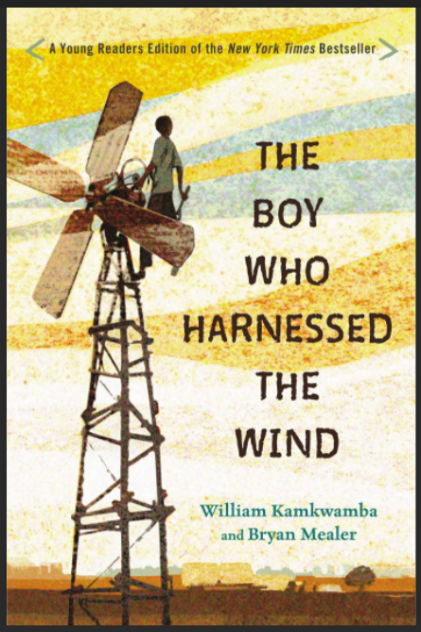
The Boy Who Harnessed the Wind
Teacher’s Guide
The Centre of Excellence for Energy
Overview
This text was selected as a read-aloud (or as part of a book club) for late elementary-middle school classes to incorporate content related to sustainability, energy, and climate change beyond science classes. We endeavour to provide resources that target literacy across all curriculums for many grade levels. Teachers are invited to pick-and-choose prompts, questions, and activities that best fit their students and classroom. At the completion of the book, feel free to contact Adam Trider (adam.trider@gnb.ca), Lead of the Centres of Excellence for Energy, on additional experiential learning opportunities in New Brunswick.

How to incorporate this read-aloud into your design for learning?
- Through a cross-curricular, cross-cultural exploration of the continent of Africa (among texts for a book club in grade 6 social studies as the focus is on culture)
- Inquiry-based, student-led, sustainability projects (connected to Earth Day)
- Participate in a Global Teenager Project learning circle on global citizenship (https://globalteenager.org/)
- Explore solution-focused thinkers or those who dream big to create, invent or discover new things to improve people’s quality of life, demonstrate global citizenship or sustainable practices (like microloans to women in developing countries), etc. https://www.gcfbi.org/causes/women-s-empowerment/microloans-for-womenns for Women - Global Children’s Fund (gcfbi.org))
- Focus on youth entrepreneurs, innovators, and those advocating for social change or environmental change. Launch a school-wide initiative to show how youth in Canada and across the globe are change-makers.
- Incorporate this novel in conjunction with a Scholastic Literacy Place Moving Up (4-6), and Stepping Up Inquiry Kits (7-8) featuring topics on sustainability, climate change, global citizenship, protecting endangered species, etc.

Questions for each chapter could:
- Be divided among small groups of students as a component of speaking/listening outcomes, guided reading activities or as a component of a cross-curricular emphasis on ELA GCO 2: to communicate information and ideas effectively

Consider using these read-aloud questions as a rehearsal of:
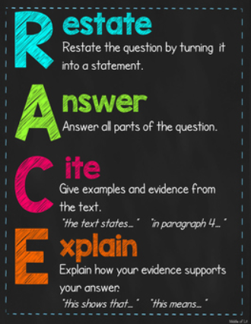
- Journal or reflective writing with personal responses to the text
- RACE strategy used to develop thorough written responses in preparation for the gr 6 assessment or gr 9 ELPA
- Independent Literature Circle roles. Invite small groups to respond to questions by practicing a specific role each class or week (Character Captain, Illustrator, Connector, Discussion Director, etc.).
- Six Thinking Hats responses
- Elements of a Story
(Characters, Plot, Setting, Conflict, Theme)
- Introduction to Figurative Language
(Personification, similes, metaphor)
- Vocabulary boosting
- Resilience & Plot development - Design a bulletin board to track William’s journey through challenges (problems) & solutions.
- As an exploration of grit and resilience as William exemplifies both qualities in the face of hardship.
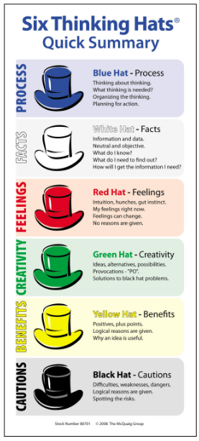
- Incorporate art or doodle summaries to invite creativity and imagination into essential skill-building like note-taking, identifying the main idea, listening for keywords/building vocabularies, etc. Consider a drawing summary of each day’s reading as a whole class or in student journals? Students could draw 3 or 4 rectangles (like a storyboard) that capture the beginning, middle and end of each day’s reading, including the main events or a highlight reel. This could include keywords, dialogue, actions, etc. This could initiate student-led discussions to summarize the reading or invite discussion about why students included or excluded certain details.
- Battle of the Prompt: In chapters with many questions, print them off, and have two students each select and read a question to the class as a daily/weekly prompt. Students can vote for the question they prefer or offer those two questions as the focus for the week.

Guiding Question Suggestions:
- How do people learn? What motivates people to want to learn? Explore learning styles, experiential learning opportunities, opportunities to learn from peers, guest speakers, etc.

- Does knowledge (or literacy) give you power? What messages might the author be communicating to the reader? Why?

- What do empowerment and disempowerment look like in our world? Why do some people maintain more power than others? What is poverty? Are power and greed synonymous (linked)?

- How does a person overcome adversity?

- How has innovation, machines, and technology impacted our world? Have they improved our quality of life or created additional challenges? Or both?

- What types of sustainability exist in our world? Where can we find evidence of economic, environmental, and social sustainability (profits, planet, and people) in our world?
- Sustainability is the practice of using natural resources responsibly today so they are available for future generations tomorrow. (https://education.nationalgeographic.org/resource/sustainability). What changes could be made to ignite more sustainable practices in your school community? In water consumption? Reducing waste and paper consumption? Reducing energy consumption?
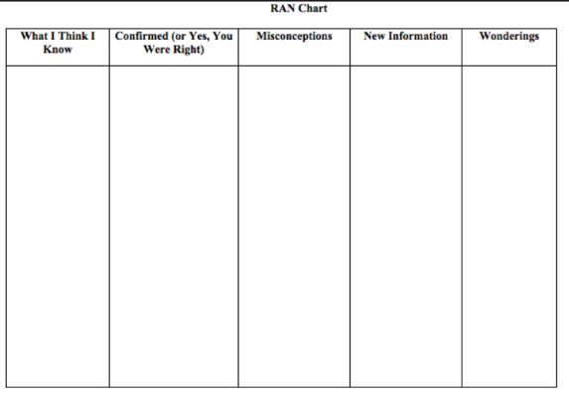
Prologue – Accessing Prior Knowledge
- Create and post a RAN chart (for non-fiction texts) that could be accessible to the class during your reading of the book.

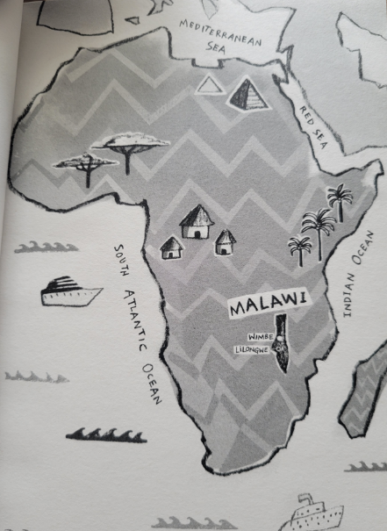
- What do students already know about Africa?
Can they identify three things they think they know about Africa that could be confirmed, recognized as a misconception, or that lead to learning or further questions through your reading of the text (Ex: political leaders from Africa; texts: books, movies, poetry; actors, athletes, historical events, etc.)?

- Identify and explain a few examples of how machines/technology have made life easier.

- “[T]hey gathered under the machine, looking up in wonder…These same men had teased me…even laughed”(2). What does this quote reveal about the character and values of William Kamkwamba? Innovators and entrepreneurs find solutions to problems or invent better ways to deal with everyday issues. Identify a scientist, innovator or entrepreneur who may have faced criticism for their ideas but is now celebrated!
Image/Geography of Africa from Prologue

- Consider the author’s word choice: “Its steel bones were welded and bent…Each piece had been lost and then found in a time of fear and hunger and pain. Together now, we were all being reborn”(2). This passage makes me think of Frankenstein! Can the class generate other connections? Make predictions about the meaning of this quote?
Chapter One – When Magic Ruled the World
- Needs & Available Resources: Discuss the ingenuity of house construction in William’s village. Identify the various materials and their purpose.

- Challenges: What are a few of the challenges William identifies in this chapter: familial, financial and medical, for instance.

- Describe the authority of the sing’anga (or witch doctor) and magic in this community.

- Culture: Explain the evidence of American culture and entertainment in this chapter.

- Why does the author say, “the world isn’t such a big place” (20)? Draw connections to the boys’ ingenuity and innovation. (Ex: toy trucks, go-carts)

- Lesson Learned: “Having superpowers was a lifelong dream” (29), and William believes Shabani will make this a reality. What does he learn from this painful experience?

- Is William a reliable narrator? Can we trust a child’s point of view to interpret their world accurately? Why or why not? As you read each chapter, consider evidence supporting or refuting William’s reliability/credibility.

Chapter Two – Khamba
- Math challenge: If William was nine years old in January 1997, in what year was he born? How old would William be today?

- Memory sort: William experiences the loss of Uncle John, and it is the first time he sees his parents cry (36). Use a ruler and divide your sheet in half. Identify “first experiences” between kindergarten and grade 8 that someone is unlikely to forget. Positive memories, proud or happy experiences are listed above the line, and negative or painful experiences are listed below. Write only what you are comfortable discussing. (Ex: Positive “first” experiences: winning any competition, succeeding on a test or project, learning to ride a bike, learning to swim, travelling to a new place, etc. Negative “first” experiences: loss of a pet or family member; illness, an accident or injury, losing a competition or contest, etc.).

Chapter Three – Discovering a Thing Called Science
- Vocabulary challenge: William states, “the radio was our only link to the world outside our village”(46). Listen and identify 5 radio-specific vocabulary words in this chapter. (Ex: portable, stations, static, circuit board, transistors, speakers, volume, casings, batteries, voltage, alternating & direct current, etc.)

- Science Sort: William says, “If finding these answers was the job of a scientist, then I wanted to become one”(51). How many fields of science can you identify? What types of questions guide researchers in this field?

- Consider the impact on your daily life if you did not have electricity. (54)

- Needs & Available Resources: Identify examples of innovation mentioned in this chapter and how the community uses available resources to meet their needs.

- What do you already know about global deforestation and its effects? Where are some places where it is occurring? Why?

- Needs: What is your reaction to William’s comment, “since we don’t have electricity…[we] rely on fire for everything from cooking to heating bathwater”(56). What problems result from being caught in this cycle of trying to meet your family’s basic needs? (without trees, storms turn into floods (56), heavy rain washes away soil and minerals (57), turbines get clogged with garbage and have to be turned off (57), and prices raised for electricity making it unaffordable (57), more people have to rely on wood, etc.

- Poverty Cycle: Why could a lack of access to education become a component of the poverty cycle and, more importantly, the ability to break the poverty cycle? (secondary school wasn’t free and required uniforms [60]).

Chapter Four – The Uncertain Life of an African Farmer
- Why is maize such an important crop in Malawi? (eaten at every meal (62-63), it is a difficult crop which takes the whole year (63). Investigate some of the essential crops in Canada. Does this vary by province and/or territory? Explain. (https://agriculture.canada.ca/en/canadas-agriculture-sectors/crops/canada-outlook-principal-field-crops-march-18-2022 - durum, wheat, barley, corn, oats, rye, canola, flaxseed, etc.; https://globalnews.ca/news/4045604/you-feel-helpless-canadas-most-profitable-crop-dealing-with-threatening-disease/)

- Word choice: What comparisons (similes) did William make regarding a good harvest? “Harvest was like…”(66). (Ex: one giant party (66), putting a million dollars in the bank”(67). Explain its meaning.

- Writing craft: Notice how the author crafts the personification of the weather: “the sun rose angry in the sky each morning and showed no mercy on the seedlings that had survived”(68). What does this convey to the audience? What is the purpose?

- Social Justice: Discuss your reaction to the new president of Malawi’s belief that it is not “the government’s job…to help farmers. So that year, the price of fertilizer was so expensive that most families…couldn’t afford to buy it”(67). Does the government have a responsibility to support the health and welfare of its people, especially those in need? Explain.
- Financial Literacy Lessons: Presented by COE Entrepreneurship & Junior Achievement Canada
Financial Literacy - Awareness for Middle School – Lesson 1: https://tinyurl.com/hr7x38rf

Financial Literacy - Budgeting for Life After School – Lesson 2: https://tinyurl.com/yvfkzpra

Chapter Five – Malawi Begins to Starve
- Class discussion or personal reaction: “In Malawi, your animals are your most prized possessions, a farmer’s token of wealth and class”(73). Explain your understanding of this quote. If you had 1 minute to grab three of your most prized possessions, what would they be? Explain the significance of each item.

- Persuasive Group Activity: Building on the quote above, examine organizations like Unicef Canada or World Vision Canada’s Gift Catalogue: https://tinyurl.com/35xbappe. In small groups, discuss: Your group has $100 to support a family in need. In your opinion, which gift helps sustain a family for many years and perhaps offers a way to end the poverty cycle? Explain your choice with at least three persuasive arguments. Consider how your class could fundraise to support a local charity, the crisis in Ukraine, or a family in need.

- Personal reflection: “What began as drought and hunger in Malawi soon evolved into full-blown famine”(78). Consider viewing the video: 1984 Band Aid “(Feed the World) Do They Know It’s Christmas Time” https://www.youtube.com/watch?v=8NLLAeNhH3k or “U.S.A. for Africa – We Are the World” https://www.youtube.com/watch?v=9AjkUyX0rVw. Do celebrities, professional athletes, or those with social influence have a responsibility to speak out for those with no voice? For those living in famine, poverty, refugees or those devastated by natural disasters, wars, etc.? Why or why not?

- Describe the personality and decision-making of William’s father based on the information we have been given and what we can infer. Consider his perspective, “…no person should have to go to sleep with an empty stomach”(79) and “We’re selling all of our food”(80).

- Text-to-Self/World Connection: William discusses the lesson of supply and demand (82). How was this evidenced during and after the Covid-19 Pandemic or during the Crisis in Ukraine? Reflect and discuss examples.

- Social awareness and response to food insecurity and famine: Symptoms of starvation – hunger, then starvation in William’s community (84, 90-95). Identify groups or organizations, like World Central Kitchen and Chef Jose Andres, responding to the need to feed Ukrainian refugees: https://www.today.com/food/news/jose-andres-feeding-refugees-ukraine-poland-border-rcna17937. What reputable groups are addressing world hunger, food insecurity and famine? SUPPLEMENTARY READING TEXT FROM NEWSELA: “Somali Communities Tap Social App to Provide Aid for Starving Clan Members” OR “Liberia's Schools See Improved Attendance with Free Meals”

- Personification/simile/imagery of the crowd: “The wave of bodies lifted me off the ground…I felt the air being squeezed out of my lungs…the mob trapped me in its belly…I drifted in slow motion, as if underwater…The crowd carried me like a cyclone”(86). Explain the author’s purpose for crafting the language in this way? What impact does it have on the reader?

Chapter Six – My School Assignment
- Abuse of Power/Social Justice: “…traders began mixing [gaga] with sawdust”(102). “The hungry people could complain all they wanted, but with no money in their pockets, they had no power”(102). To what extent does power or the lack of power affect the individuals in this chapter? Ex: “many of you still haven’t paid your school fees for this term. Starting tomorrow, the free period is over”(111).

- Personal response: How could this text motivate social awareness and change among readers? Have you read or heard something that inspired you to want to help address a community need or to raise awareness about a concern? Explain if you know someone who has participated in a fundraiser, supports a local charity, or volunteers in their community. What motivates someone to become involved? Or why do they think it’s important to help?

- Greed, stealing, violence to secure food and meet basic needs (102-3). Is it right?

- Compare and contrast: Create a VENN diagram and compare how your education is similar to William’s experience and then contrast how your educations are different.
(Education – uniforms/shoes; condition of the school; books; “All day my stomach growled and gave my brain no peace, and soon it was too difficult to pay attention”(110) 20/70 remained at school (113)

Chapter Seven – A Time of Dying
( A word of caution: In this chapter, many die due to starvation and disease. William is faced with the heartbreaking decision to end his dog’s life. The dog is suffering, and the family does not have food to feed him. This chapter may be too sensitive to read out loud.)

Chapter Eight – Twenty Days
- Emotions List: William states, “Cholera is a highly contagious infection that causes severe diarrhea”(128) and dehydration. It “…spread[s] like grassfire…every rainy season…[when] the rains…pollute the wells and streams where people drink. Blowflies also spread the bacteria after crawling out of toilets and landing on food”(128-9). Identify in a list “feeling words” or emotions that might describe this community during this outbreak.

- Personal response: “…a stomach filled with warm food was one of the greatest pleasures in life”(135). Using rich sensory detail, make your classmates hungry by describing your greatest food pleasure (favourite meal) in a descriptive paragraph.

Chapter Nine – The Library
- Personal Response: William reaches the reading zone saying, “For the first time in my life, I experienced what it felt like to escape without going anywhere”(139). Finish the following line with strong similes (comparisons): To me, reading is like… Compare responses among the class. Explain how a reader’s overall engagement may depend on finding a good-fit book. Should readers have more choices in classroom texts? Why or why not? Explain.

- Through his reading, William discovers the Nkula Falls where “ESCOM operated the hydro plant…where the country got its electricity…the water turned a giant wheel at the plant called a turbine, and the turbine produced the electricity”(141). If students are unfamiliar with this process, explore provincial connections through the NB Power website: https://www.nbpower.com/en/about-us/learning/learn-about-electricity/hydro/.

- Watch the video created in collaboration with The Gaia Project on the Mactaquac Generating Station to learn more about Hydro Power (found on the same webpage listed above).
HYDRO
Water plays a very important role in the creation of electricity in New Brunswick. Hydroelectricity, when the power of falling water is turned into electricity, has been used for hundreds of years and is one of the most efficient ways to produce electricity.
It's also good for the environment because it’s a renewable energy source that has little environmental impact and doesn’t emit greenhouse gases. We currently have 7 hydro stations throughout New Brunswick, which makes up half of all of our generating stations.

- Vocabulary challenge: Identify 5 science-energy-specific vocabulary words in this chapter. (Ex: voltage, resistor, magnets, poles, iron core, coil, magnetic field, conductor, motors, electromagnetics, current, turbines, switches, etc.) Organize words in alphabetical order and discuss as a group the vocabulary terms based on common or uncommon connections. OR use a few of the longer words on the lists for a game of BOGGLE (use each letter in the word once only to generate a new word list).

- In Using Energy, William observes a “long row of windmills…tall white towers with three blades spinning like a fan”(147). “Sometimes energy needs to be converted to another form before it is useful…Just like the sun, windmills could also be used to generate power…also pump water. A windmill meant more than just power. It was freedom.”(148-150). Please consider engaging your class in one of the energy activities featured on the Centres of Excellence for Energy website. Examples: What is Energy? - https://centresofexcellencenb.ca/energy/?learning_activity=what-is-energy; Energy Games and Puzzles - https://centresofexcellencenb.ca/energy/?learning_activity=energy-games-and-puzzles; Solar Power - https://centresofexcellencenb.ca/energy/?learning_activity=solar-power-and-energy-calculations; and Adam can facilitate an activity with students on creating wind turbines in connection with William’s story.

For more information on the evolution of windmills, view the Gaia Project & NB Power Video on “Demystifying Wind Energy” via COE Energy Speaker Series Videos (section begins around 4.15min) - https://centresofexcellencenb.ca/energy/?speaker_series=demystifying-wind-energy OR view the “Wocawson Energy Project” video also found on the COE Energy Speaker Series Videos https://centresofexcellencenb.ca/energy/?speaker_series=wocawson-energy-project.

- Quickwrite Using Lists: “…I didn’t have the right kind of tools, so I had to improvise.”(152). William has to improvise or imagine how everyday objects could be used for a different purpose. Assemble a collection of things from your classroom into a bag. For this quickwrite, leave an object for every small group – students work individually at first to list new and improved, imaginative purposes for those objects. Then compare their lists with their group. How many purposes can they improvise/imagine for the object?

Chapter Ten – Harvest Time
- Identifying Fears: One of William’s fears is that if he can’t go to school, with no education, he would “end up just like [my father], another poor Malawian farmer”(171). He also: “I began to fear my windmill would never get built”(184). List some common fears that children and adults face.

- Discuss the figurative language (mostly similies) listed below. What is being compared? What is the deeper meaning created by this comparison:
“[T]the maize rows appeared like bars of my own prison”(171).
“[A]t night we slept like lions with bellies full of food”(172).
“[T]he treasures kept revealing themselves like pieces of a magic puzzle”(179)
“[M]y blades leaned against the wall like giant insect wings, their white surfaces scorched like a burned marshmallow”(183)
“The tractor fan looked like a super Chinese throwing star – one that would slice through the darkness leaving a trail of light”(183)
“…I found a perfectly good motor stripped of its wires. It lay there dead in the grass like one of those poached elephants missing its tusks”(184)
“…I wanted to make sure the blades were connected…strong and wouldn’t snap in a heavy wind. So I wired three-foot bamboo reinforcements to each one, to where they acted like bones”(188).
“However, from a short distance away, [the windmill’s] long and spindly legs gave it the appearance of a wobbly giraffe”(195).

- Personal Response: “More and more, going to the scrapyard began to replace school in my mind. It was an environment where I learned something new each day…My imagination was constantly at work.”(177). Is there something you’ve always wanted to know more about? An issue, exploring something new, making an idea come to life by finding a better way to monitor health, wellness, etc. Or do you want people to understand an issue in a new way? Where does your imagination come alive?

Through the Centre of Excellence for Entrepreneurship website, teachers can access an Idea Market Kit or PitchFest resources, both inquiry-based, student-led projects that allow students to explore their interests, talents and questions about the world. These resources have been created as a guide to facilitate this type of experiential learning.

- Solution-Focused rather than Problem-Based Thinking: Inventors, scientists, researchers, or entrepreneurs may be seen as crazy, strange, risk-takers, etc. His community saw William as “the madman…with his garbage”(182) or “a lazy boy who plays with toys and refuses to work”(182). How do you learn to silence the critics, even the critic in your mind, when you dream big? Write a response today where you give advice to William.

- Everyone needs a Gilbert – socially-conscious loans, someone who believes in the dream!

Chapter Eleven – The Windmill Comes to Life
- As William’s dream came to life, it inspired bigger dreams and plans. The first windmill was for light or charging mobile phones (208). The second "would pump water for our fields and give us more food. Windmills would be our front line against hunger”(206). Identify other ways in which to inspire sustainable practices for communities all over the world, especially those in water crisis?

Chapter Twelve – Bigger and Brighter
- Observation Challenge: Spot the Transformers
“Because electricity gets lost on the journey from the power station to your home, the company installs transformers along the way that add that extra boost. It’s like giving your electricity some coffee and doughnuts to keep it going”(210). Watch for transformers in your community this week and report to the class.
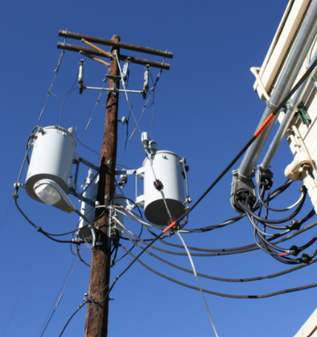
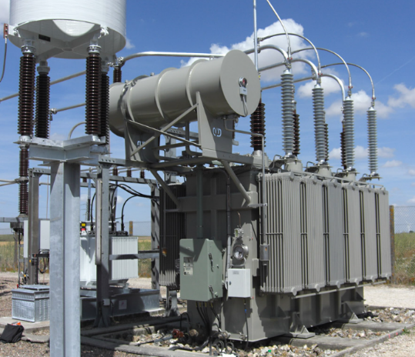

- Design a Transformer toy that reflects William’s personality.

- Mechanically Minded: Can anyone describe an experience working on a piece of machinery or a car/vehicle with a belt? What do they do? Why are they important tools?

Chapter Thirteen – The Restless Inventor
- Personal Reaction: What did William fear? What helped him maintain his inspiration and a positive mindset (227)? What about you? What enables you to maintain a positive attitude?

- Prototypes & Model: William’s next goal was to build a water pump (231). What are the advantages or benefits of building a model or prototype for engineers, inventors, or innovators?

- Supplementary Reading: Investigate Canadian innovator Ryan Hreljac’s efforts in sustainable solutions to the water crisis:

https://www.ryanswell.ca/about-ryans-well/; https://www.readersdigest.ca/culture/ryans-well/

Ryan’s Well Foundation is a Canadian charitable organization providing effective and sustainable solutions to the water crisis in the poorest regions of the world’s developing countries. The Foundation grew from the passion and courage of one 6-year-old boy, Ryan Hreljac. Ryan was inspired to take action as a grade one student when he learned of the devastating consequences for people without access to safe drinking water. He was remarkably determined as he succeeded in rallying his community to help him raise the funds needed to build one well in Uganda, Africa – one well that has changed everything. Now, more than 20 years later, Ryan’s Well Foundation is a team of people committed to providing access to safe water and sanitation as an essential way to improve lives in the developing world. We also educate people about the importance of accessing safe water and sanitation services and look to motivate people of all ages to take action and effect positive change in the world.

- Personal Reaction - Gender Norms/Social Justice: “In Malawi, this is every woman’s burden. And I knew these journeys to find wood would only get longer and longer. Plus, the deforestation would only create more devastating droughts and floods”(233). In your opinion, why does William say finding wood is a woman’s burden? Explain what you can infer (read-between-the-lines) from this quote.

- Humor: Explain William’s conundrum with biogas (235-237) – “converting animal poop into fuel to use for cooking.”
Chapter Fourteen – The World Discovers Wimbe
- Personal response to the following: “So many things around you are reusable…Where others see garbage, I see opportunity…If we can all invent something to make our lives better, we can change Malawi” (243). Identify ways people use garbage to create art, recycle products to make new products, etc. Or ways your family or grandparents recycled materials to meet their needs (Ex: material flour bags or used suit coats to make quilts; bread tags used to make bowls: https://www.abc.net.au/news/2019-07-26/recycling-bread-tags-into-bowls/11342298)

- Dr. Hartford Mchazime interviews William then various journalists about his inventions which lead to the opportunity to participate in the TED Global Conference [Technology, Entertainment, and Design – “an annual meeting where scientists and innovators…share their big ideas”(251): https://www.ted.com/talks/william_kamkwamba_how_i_built_a_windmill

Chapter Fifteen – Meeting Ted and Tom
- Geography Grabber: Mount Kilimanjaro – Conduct quick research on the highest peaks in the world. In what countries are these mountains found?

- Energy Efficiency & Health: Explain how some of the new materials improved the efficiency of William’s windmill, community and the overall wellbeing of his family. (Ex: deep-cycle batteries, solar lamps, energy-saving bulbs, buried lines, solar panels, doctor visits, irrigation, access to clean water)

- Culture and education: What challenges might exist for a student from Africa experience following an online “distance-learning curriculum from America” (272), primarily related to content?

- Personal Reaction to Empowerment & Disempowerment: Reflect on William’s comment, “Americans could build a skyscraper in a year, but in four decades of independence, Malawi couldn’t even bring clean water to a village” (276). Thoughts about social responsibility? Access to information, etc.?

- Visualization Activity: “…miles upon miles of windmills. More than six thousand of them, shooting from the ground like giant mechanical trees…hundred-foot blades two-hundred feet in the air…a wingspan longer than [an] airplane…” (277). Pause for a moment and imagine the sound of thousands of windmills gracefully spinning, the height of these machines, consider their design, especially the propellors, and how they might be spaced out in relation to the landscape to capture the wind, etc.

- Explain the meaning of coming “full circle” (278) and how William feels at this point in his journey and discovery.
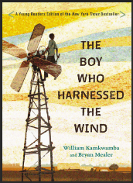
The Boy Who Harnessed the Wind
Mini-Projects Choice Board
Considerations for all projects:
- projects should reveal and represent your knowledge of the novel in a creative way
- rough copies must be presented in a minimum of 2 conferences: one conference to revise ideas/content and another conference to edit spelling, grammar and punctuation problems
- rough copies will be included with your final project
10 Collection  Tap into your creativity and select a minimum of 10 items to summarize the plot, conflict, narrator, setting, etc., of the novel (paint, wire figurines, cardboard cut-outs, felt stitching, intricate drawing/painting collage, etc.). | Character Sketch  Create a full-body silhouette of the novel’s narrator (or a significant person). Find details from the novel to describe his/her physical description (what does the character look like), how s/he feel (heart), what/how does s/he think (head), their actions/main events (arms or legs), what are some of the most important things this individual says (mouth), etc. | Diorama or Video  Construct or create a diorama/model of one of the most significant moments in the novel either in a shoebox, as a sculpture or painting, or consider making a stop-action animation using Lego. Or dramatically recreate a scene – act it out!
Traditions on the Menu  Reconstruct a menu of food items featured in this novel, which were staples in William’s diet. You can prepare a few dishes for classmates to try or recreate those foods using any craft material. | Author Letter  Write and send a personal letter to the author describing your reaction to the book, what you enjoyed, how his story inspired you, etc. List 3-4 questions you’d like for him to answer. | Song/Poem  Summarize the plot and conflict of the book in a poem/lyrics, or on William’s journey, etc.
I Am Poem  Create an “I am…poem” or a Biopoem for William or one of the significant people from the book. | Children’s Story/  Reader’s Theatre  Write a children’s story with illustrations or a reader’s theatre play with a strong connection to a theme/message found in “The Boy Who Harnessed the Wind”. | Movie Review  A movie adaptation of the novel is available on Netflix. Students can watch the movie and either consider creating a graphic organizer to compare/contrast the film and the book or write a movie review.
Playlist  Create a playlist of 3-4 songs that might be included as a soundtrack for the novel. The theme of each song should  reflect the conflicts faced by William, his journey, and the conclusion of the novel, for example. | Ted Talk/Pitch  Organize a Ted Talk speech to educate your class about an issue that concerns you; write a speech to inspire or persuade others, etc.  Pitch an idea about an invention or a machine to make lives easier, like Dragon’s Den or Shark Tank. | Travel Tracker  Use or construct a large world map to trace William’s journey. Incorporate interesting facts and details about the community/area where William grew up, geographical features, animals, typical occupations, etc.

Student Self-Assessment Name: _______________________
Reflection upon completion of The Boy Who Harnessed the Wind projects.
Write on the back of the sheet if you need more room.

- Of what am I most proud? What shows my best effort? Why?

- Where did you take a risk (to try something new or venture outside your comfort zone)?

- In what area or areas did you struggle? Explain why if possible.

- What would you do differently next time?

Writer to writer:
- What did you learn about yourself as a writer during this project?

- Where could you use specific instruction to improve your writing? Set two writing goals for yourself.

Overall ratings:
- How challenging did you find The Boy Who Harnessed the Wind to read, not just in terms of vocabulary but in terms of ideas and content? Rate on a scale from 1 (extremely challenging) – 10 (extremely easy). Would you recommend this book to others? Would you recommend grades 3-8 teachers use this text? Why or why not?

- What would you give yourself as an overall mark on this project/s? Why?

Project Evaluations
Presenter/s: ________________________________ Project: __________________________ Date: _________________

 | No Evidence Noted | 1  Areas for  Improvement | 2  Approaching | 3  Meeting | 4  Excelling
Strong presentation and explanation of project (loud voice, eye contact, enthusiasm, engaging)
Project is well-organized; demonstrates planning and effort; easy to understand with many relevant details
Few errors in conventions (grammar, spelling, punctuation, etc.,) which do not take away from meaning
Strong connections to the novel; critical thinking evident

Final Mark

----------------------------------------------------------------------------------------------------------------------------------------------------------------
