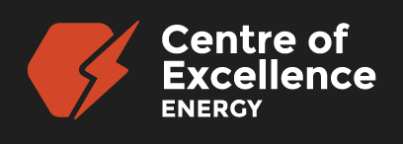
The Boy Who Harnessed the Wind Activity Guide
Grades 2-5
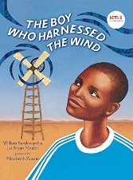
Overview
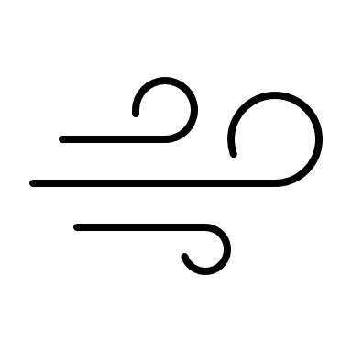
Imagine the power of a young boy’s knowledge, creativity and determination literally changing a community forever! Students will be inspired to put their own learning and imagination into action after reading the picture book, “The Boy Who Harnessed the Wind” written by William Kamkwamba and Bryan Mealer. This guide provides pre-reading activities, as well as a wind energy building challenge for students in grades 2-5. We hope, that through these activities, the wind will serve as a reminder of what true innovation can bring!

What You’ll Need
- Copy of “The Boy Who Harnessed the Wind” by: William Kamkwamba & Bryan Mealer  - Chart Paper  - Wind Design template (see below, photocopies needed per student or group)  - Fan (for testing windmills) | - Pencils  - Maker Space Materials: recyclables, paper, cut up sponges, tape, scissors, newspaper, straws, fasteners, unsharpened pencils, etc. (see activity below for more suggestions)  - SmartBoard (Google Earth) or World Map

Instructions
- PRE-READING:
Wind
- Discussion: On a piece of chart paper, print the word – Wind. Ask students to describe what they first think about when they hear this word. Write down their responses.

- Context: Using a world map or a website like Google Earth (https://earth.google.com/web/) show students the country of Malawi. Talk about the countries around it, how it is a land-locked nation, as well as how far away it is from the ocean. Known as the “warm heart of Africa”, Malawi has been experiencing the affects of climate change for quite some time. The country is particularly prone to dry spells, seasonal droughts, intense rainfall, riverine floods, and flash floods.¹ This is particularly challenging because Malawi relies heavily on agriculture (crops, production and exports) for its economy.

- AFTER READING:
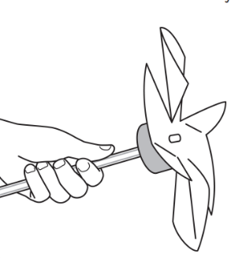
a ) Build Your Own Windmill Challenge!
Divide your students into small groups or partners. Have a variety of materials available. Then, see the activity guide below for all steps needed to complete the windmill challenge. The ultimate goal: to create a windmill that spins in the wind! The possibilities are endless and no two windmills need to look the same.

- REFLECTION: Go back to the original chart paper of Wind and have students add to it. How does wind energy affect me? How does it affect our province of New Brunswick? Check out NB Power’s Wind Energy site: www.nbpower.com/en/about-us/our-energy/wind-energy.

- SHARE: Feel free to send us photographs of your class completing this learning activity via Twitter @NBCOE. For additional learning opportunities, reach out to the Centre of Excellence for Energy’s Lead, Adam Trider @ adam.trider@gnb.ca.

If You Liked, “The Boy Who Harnessed the Wind”, may we suggest:
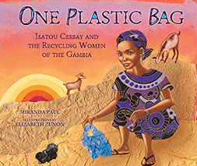 | 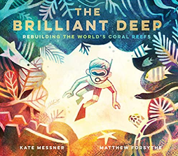 | 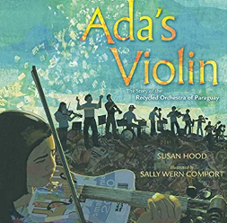
One Plastic Bag: Isatou Ceesay and the Recycling Women of the Gambia  By: Miranda Paul  Illustrated by: Elizabeth Zunon | The Brilliant Deep: Rebuilding the World's Coral Reefs  By: Kate Messner  Illustrated by: Matthew Forsythe | Ada’s Violin  By: Susan Hood  Illustrated by: Sally Wern Comport

Curriculum Outcomes
Science | GCO 2: Students will develop an understanding of the nature of science and technology, of the relationships between science and technology, and of the social and environmental contexts of science and technology (STSE).  Concepts Included:  Grade 3 - Interactions of living and non-living components ▪ Energy flow  Grade 4 - Uses of Earth resources – wind  Grade 5 - Common simple machines, different types of forces
Literacy | GCO 1: Students will speak and listen to explore, extend, clarify, and reflect on their  thoughts, ideas, feelings, and experiences.  GCO 2: Students will be able to communicate information and ideas effectively and  clearly, and to respond personally and critically.
Personal Wellness | GCO 4 Students will develop knowledge of self and explore the world of work.
Social Studies | 4.3.3 Examine the relationship between humans and the physical environment.

Global Competencies
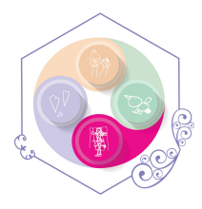 | 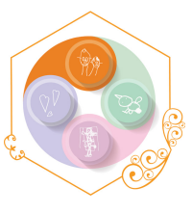 | 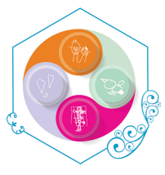 | 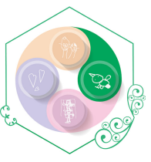 | 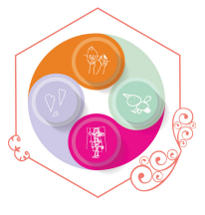 | 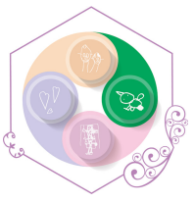
Collaboration | Communication | Critical Thinking & Problem-Solving | Fostering and Teaching Self-Awareness and Self-Management | Innovation, Creativity & Entrepreneurship | Sustainability and Global Citizenship

Acknowledgements
1. Climate Change Knowledge Portal - https://climateknowledgeportal.worldbank.org/country/malawi/vulnerability
NB Power - Wind Energy (nbpower.com)
A huge thanks to Recharge Labs (www.rechargelabs.org) for the use of their Mini Windmills Class Pack Activity Guide.

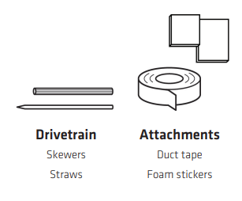
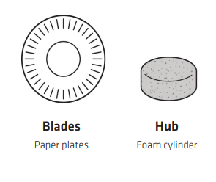
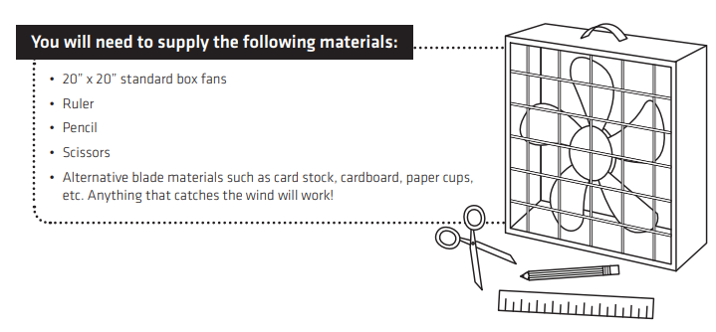
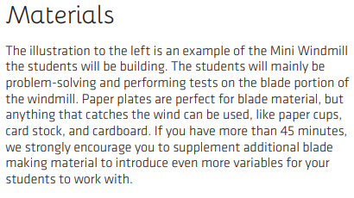
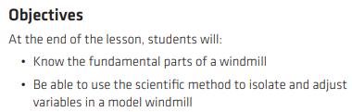
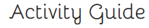
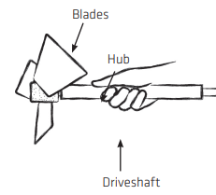
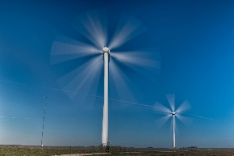
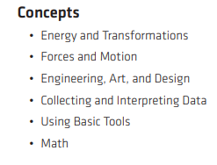
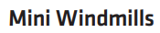
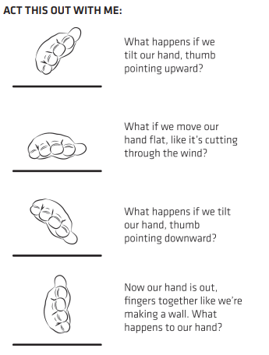
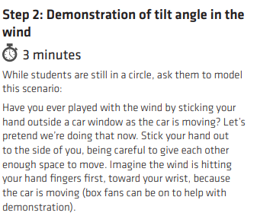
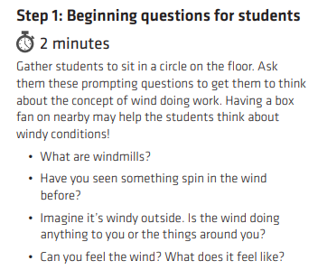
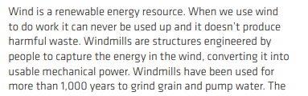
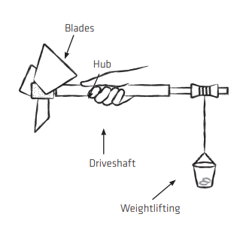
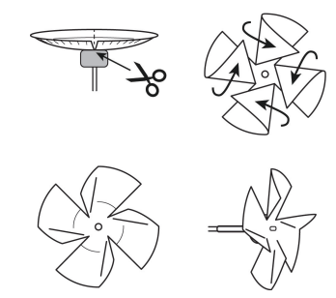
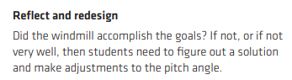
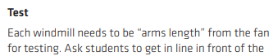
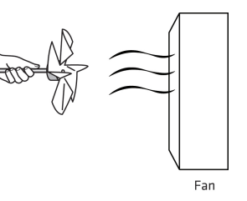
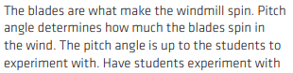
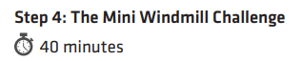
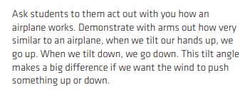
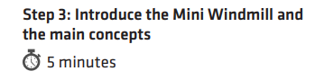
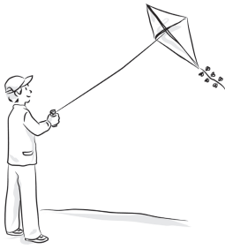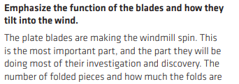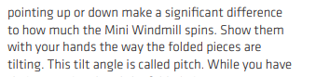
Challenge: For students needing an extra task, get them to add weights and see if their windmill can lift them up as it spins!

