 **Earth Day Action Bingo**

**2025**

For every Bingo square, find details, links, printables and ideas to help your class choose the ACTION STEPS best for them and their BINGO!

1. **Re-read WHAT MATTERS & do an Extension Activity:**

* Make a list of things you can do in your neighborhood to help animals.

(What kind things can you do so animals can live happily near your home?)

* Can you name the animals and plants from the story?

(Think about the story you read — which animals and plants were in it?)

* Make up your own story about helping the Earth while walking in your neighborhood.

(As you walk, what do you see? What nice things do you do for nature?)

1. **Create New Brunswick Endangered Species Postcards:**

Using this CPAWS (Canadian Parks and Wilderness Society) Teacher Resource [Have you ever heard of an endangered species (cpawsnb.org)](https://cpawsnb.org/wp-content/uploads/2018/03/Teacher-Resource-2017-eng-WYP.pdf), discover endangered species in New Brunswick (on page 4) – plants and animals. For K-2 classes, pick one species to research and create postcards to deliver to another class(es), to spread the word! For 3-5 classes, allow students to choose an endangered species individually or in partners and then create a postcard to share and spread the word! Use the postcard template in the Appendix to help with the creations.

1. **Complete a Wabanaki Languages Outdoor Scavenger Hunt:**

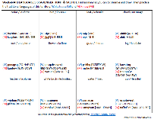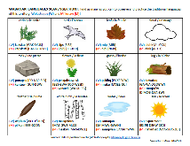Individually or in small groups, have students find as many items on the list that they can while also practicing the traditional languages of Wolastoqey and Mi’kmaw. Choose from two scavenger hunts that were created by Elder Opolahsomuwehs (Wolastoqewiyik) and Janelle LeBlanc (ASD-S) in the Appendix.

**4) Try a K-5 Sustainability Project from Gaia:**

Choose 1 of 10 engaging activities to spark environmental enthusiasm in your learners! Follow the link and sign-up to receive the complete PDF document to choose an indoor or outdoor learning experience for your class: [https://thegaiaproject.ca/en/resources/elementary/?modal=k-5-sustainability-action-projects](https://can01.safelinks.protection.outlook.com/?url=https%3A%2F%2Fthegaiaproject.ca%2Fen%2Fresources%2Felementary%2F%3Fmodal%3Dk-5-sustainability-action-projects&data=05%7C02%7CAmy.Tompkins%40gnb.ca%7C9eb6958683214756fe6d08dc2d7328ed%7Ce08b7eefb5014a679ed007e38bfccee7%7C0%7C0%7C638435219828281458%7CUnknown%7CTWFpbGZsb3d8eyJWIjoiMC4wLjAwMDAiLCJQIjoiV2luMzIiLCJBTiI6Ik1haWwiLCJXVCI6Mn0%3D%7C0%7C%7C%7C&sdata=9NPUgXMOst4dvcTPNOLgAm1OHxNQ%2BtjRZ%2B46zlg79Nc%3D&reserved=0)

**5) Create Earth Day Raps with Beastbox:**

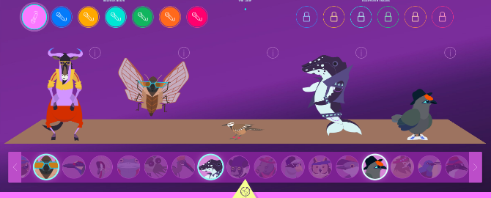The Cornell Lab of Ornithology has teamed up with wildlife DJ and beatboxer, Ben Mirin, to present Beastbox. This website (it can also be used on a Smart Board, iPad, laptop, etc.) gives students the opportunity to mix real-life wild animal voices with beatbox loops. Tie in with April’s Poetry month and have students write 4 or 8 lines all about Earth Day to accompany their chosen track. Students can perform for their peers! <https://academy.allaboutbirds.org/features/beastbox/>

**6) Create Classroom Signs to Save Energy & Water:**

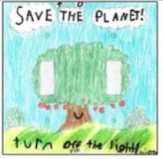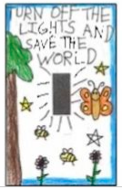On Earth Day, it may be easy to remember to do the little things in the classroom to save energy and water. Using white paper, have students create reminders around sink faucets, technology stations, light switches, the Smart Board, and larger electronics to save energy everyday. Students can create these individually or in small groups. With permission, create signs for hallways, bathrooms, and other school rooms.

 **7) Organize a School Grounds Clean-Up:**

Take a few garbage bags outside and divide up areas on your school grounds to pick up litter. Is there one area with more garbage than the rest? Discuss a solution! (Signs, announcements, an extra garbage can, a recycling container, etc.)

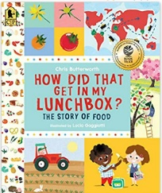**8) Lunch Box Traces:**

Have students choose 1 item from their lunch box (or hot lunch order). Using the printable in the appendix, have students draw their item and see if they can trace it back to a local food source (farm, farmer’s market, bakery, etc.)? Discuss why locally grown food helps the environment. Name local farms near your school – what do they grow? Feel free to use these sources to help look up local food traces, farms, and farmer’s markets:

Read: How Did That Get In My Lunchbox? By: Chris Butterworth (available on Sora)

Agriculture in the Classroom NB: <https://www.aitc-aec-nb.ca/farmer-contact-list>

New Brunswick Farmer’s Markets: <https://www.farms.com/rural-lifestyle/farmers-markets/new-brunswick.aspx>

Eating locally grown food impacts the environment in many positive ways: it doesn’t need to be transported (reduces greenhouse gas emissions), it has passed some of the highest food safety standards (regarding additives, pesticides, herbicides, etc.), it may have a higher nutrient value (may be given more time to ripen), less waste and packaging, and it benefits the local economy.



**9) Have a Picnic Lunch Outside (if weather permits):**

Whether on blankets, picnic benches, or grassy areas, enjoy eating outside. For younger classes, why not have a teddy bear picnic and invite students to bring their favourite stuffed animal to attend, as well.

**10) Read Another Earth Day Book:**

Grab another great read aloud from your own stash or read one of these titles via SORA (free for NB educators: <https://soraapp.com> ) to display on your Smart Board or projector:

|  |  |  |  |  |
| --- | --- | --- | --- | --- |
| **Here We Are: Notes for Living on Planet Earth**  By: Oliver Jeffers | **Earth Heroes**  By: Lily Dyu | "The Sea Book" (ebook) cover**The Sea Book**  By: Charlotte Milner | "Only One" (ebook) cover**Only One**  By: Deborah Hopkinson | **LEGO Amazing Earth**  By: Jennifer Swanson |

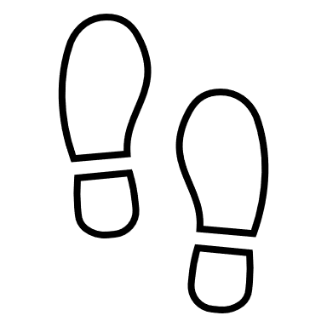

**11) Go on a Human Impact Walk:**

For this walk, plan a route where the impact of human activity is clearly visible (e.g: an industrial area, by or through a shopping mall, or even a well-used trail in the woods or a park). Ask students to imagine what the place might be like if people had never been there. *What might be here that isn’t? What is here now that might not be? How might the land have looked 50 years ago? A hundred? A thousand? How might we reduce our impact on the area now or restore features that have been lost?* Students can complete writing or drawing exercises imagining what the area looked like in the past and envisioning what it might look like in another hundred years if the human impact continues.

Excerpt from: *A Walking Curriculum: Walking, Wonder, & Sense of Place (K-12)* by: Gillian Judson, pg.43-44.

**12) Try a Recycled Art Project with Recyclables Saved Up:**

Using the recycling bin in your classroom OR by asking students to bring in 1 recyclable item from home, create recycled art to showcase in your school. Here are some ideas, but feel free to try one of your own:

|  |  |  |
| --- | --- | --- |
| **Arty Crafty Kids | Art | Cool Cat Newspaper Art for Kids | A fun recycled cat art project using recycled newspaper and magazines. With the help of a free template kids can make a cat that can strike multiple cool poses!Recycled Paper**  Using a variety of recycled papers, create a variety of cat poses.  [**https://www.artycraftykids.com/art/cool-cat-newspaper-art-project-for-kids/**](https://www.artycraftykids.com/art/cool-cat-newspaper-art-project-for-kids/) | **Water Bottle Fish Craft-2Recycled Water Bottles**  Create a display to bring awareness of the plastic in our oceans and the impact it is having on our sea creatures.  <https://meaningfulmama.com/water-bottle-fish-craft.html> | **Recycled Cardboard**  Printmaking with cardboard for kids  Try printmaking using recycled cardboard and paint.  <https://www.whereimaginationgrows.com/printmaking-recycled-cardboard-art/> |

**13) Play an Animal Game:**

* 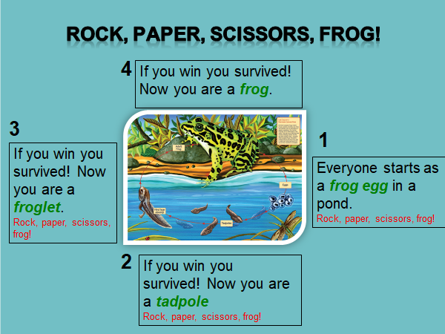**Rock, Paper, Scissors, FROG!** by CPAWS to help spark discussions of Human Impacts, Predators, and Competition in the animal kingdom. [Rock, Paper, Scissors, Frog! - CPAWS Southern Alberta (cpaws-southernalberta.org)](https://cpaws-southernalberta.org/education-program/rock-paper-scissors-frog/)
* **“Who Am I?”** Game by CPAWS (Canadian Parks and Wilderness Society) to Identify New Brunswick animals: English version: <https://cpawsnb.org/wp-content/uploads/2020/04/Who-Am-I-Game-with-CPAWSNB-b.pdf>
* **Midden Memory** Game by CPAWS to test if your memory is as good as a squirrel! [Midden Memory - CPAWS Southern Alberta (cpaws-southernalberta.org)](https://cpaws-southernalberta.org/education-program/midden-memory/)

**14) Go on a WORLD Adventure in your classroom:**

Choose an adventure below to explore the four corners of our amazing EARTH:

* Climb Mt. Everest - [Street View Treks: Everest Base Camp – About – Google Maps](https://www.google.com/maps/about/behind-the-scenes/streetview/treks/the-worlds-highest-peaks/)
* Virtual Trip to Antarctica - [Virtual Visits to the Polar Regions - British Antarctic Survey (bas.ac.uk)](https://www.bas.ac.uk/polar-operations/life-in-the-polar-regions/virtual/)
* Explore the Secrets of Ancient Ruins - [Experience Machu Picchu in Virtual Reality. (youvisit.com)](https://www.youvisit.com/tour/machupicchu)
* LIVE CAMS – Northern Lights and Animals from Around the World - [Northern Lights Live Cam - watch the Aurora Borealis | Explore.org](https://explore.org/livecams/zen-den/northern-lights-cam)



**15) Play Outside and simply ENJOY!**

**16) Plan 1 hour of your day with NO lights and NO electronics:**

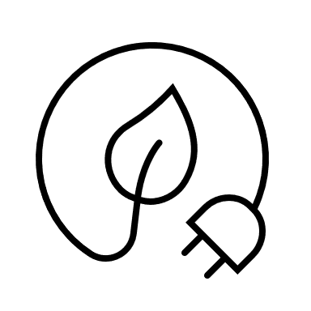Be strategic and commit to saving energy for 1 hour of the school day! Be sure to look over the schedule and have students share when they think a great time would be to do this. If possible, why not go for more than 1 hour? Just be sure to create a sign on your classroom door for anyone passing by – it may catch on!

**17) Take Macro Photographs of Nature for Your Own Art Gallery:**

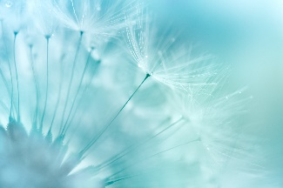Using iPads or available cameras, have students in small groups take a walk on the school grounds and take a photograph of a natural item up-close (e.g: flower, blade of grass, insect, tree bark). Feel free to print in black or white (or colour, if available) and display them. Even have students try to guess what the natural is as a “guessing game”. Discuss the details of these natural items that a photograph captures but not always our eye sees.

**18) Watch NB Recycle talk about recycling and create posters:**

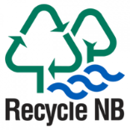After viewing one or more videos from Recycle NB, have students create posters (on white paper) to bring awareness to items that are being recycled and repurposed, but might not be known to the general population.

Videos: <https://www.recyclenb.com/videos> (available in both French and English – choose language preference at the top of the webpage.)

**19) Identify Renewable and Non-Renewable energy sources in NB:**

**For Grades K-2:** Check out The Boy Who Harnessed the Wind Activity on the Centres of Excellence for Energy website. The book (available on Sora) is an inspirational tale of how a young boy saves his village by wind power! The activity invites students to experiment and tinker with wind power, building working windmills using recyclable materials. <https://centresofexcellencenb.ca/energy/?learning_activity=the-boy-who-harnessed-the-wind-picture-book-guide-for-grades-2-5>

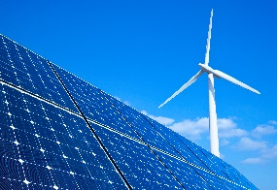**For Grades 3-5**: Atlantica Centre for Energy has created an interactive map highlighting all of NB’s Energy resources: [New Brunswick’s Energy Resources – Atlantica Centre For Energy (atlanticaenergy.org)](https://www.atlanticaenergy.org/energy-knowledge-centre/energy-maps/new-brunswicks-energy-resources/) Discuss what the difference is between renewable and non-renewable energy sources. How will this impact New Brunswick in the future?

For additional information on Renewable Energy see:

English - [CER – Canada's Renewable Power – New Brunswick (cer-rec.gc.ca)](https://www.cer-rec.gc.ca/en/data-analysis/energy-commodities/electricity/report/canadas-renewable-power/provinces/renewable-power-canada-new-brunswick.html)

French - [REC – L’électricité renouvelable au Canada – Nouveau-Brunswick (cer-rec.gc.ca)](https://www.cer-rec.gc.ca/fr/donnees-analyse/produits-base-energetiques/electricite/rapport/electricite-renouvelable-canada/provinces/electricite-renouvelable-canada-nouveau-brunswick.html)

**For Grades 3-5 : Energy Engineers :** Check out Gaia’s complete Learning Package with videos, books, key terms and 6 engaging activities! <https://thegaiaproject.ca/en/resources/elementary/?modal=k-5-sustainability-action-projects>

**20) Plan a Litterless Snack for Morning Recess:**

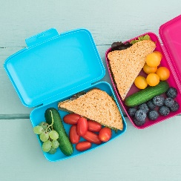Understanding that not every student may be able to participate, give students ideas on what a litterless snack can be and encourage most to participate. Examples: any food item in small containers or cloth/reusable baggies.

**21) Go PAPERLESS today in all Classroom Activities:**

This one may mean being very selective in the other activities that you choose on the BINGO grid. 😊 Instead of printing paper activities, have students come up with ideas on how NOT to use paper this day while still keeping most of your regular routines in place.

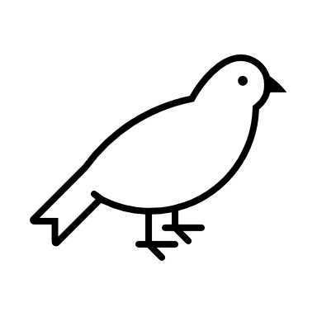

**22) Build Bird Feeders for your Outdoor Spaces:**

Get creative! Check out these ideas for DIY bird feeders: [25+ Popular Easy DIY Bird Feeders You Need to Make With The Kids - This Tiny Blue House](https://www.thistinybluehouse.com/easy-diy-bird-feeders/)

Check out which birds we have here in New Brunswick: [New Brunswick, CA · iNaturalist Canada](https://inaturalist.ca/places/new-brunswick#taxon=3)

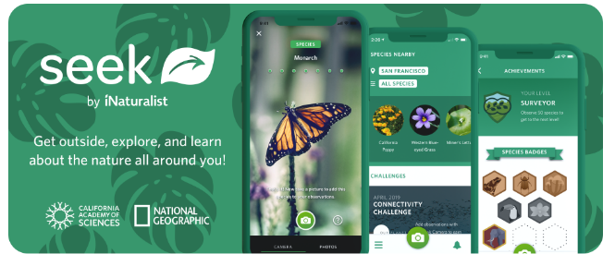**23) ID Plants & Trees in your School’s Outdoor Space with the Seek app:**

Free in the App Store and available in district catalogues (with iPad requests), Seek allows students to take a photograph of a plant or animal outside, and then gives them information on that species, using image recognition technology. <https://www.inaturalist.org/pages/seek_app>

**24) Plan and DO an Action Item that YOU create as a Class:**

The possibilities are endless! Already part of an environmental project? Count that, too! We also recognize that there may be a specific act that you and your students would want to do that would directly impact your classroom, school, or community.

**Acknowledgements:**

Cornell University, Bird Academy: Beastbox – <https://academy.allaboutbirds.org/features/beastbox/>

Victoria News, 2022: Greater Victoria students create art to promote energy conservation - <https://www.vicnews.com/community/greater-victoria-students-create-art-to-promote-energy-conservation/>

McGill University, 2023: The benefits of eating local foods – <https://www.mcgill.ca/foodservices/sustainability/green/local#:~:text=It's%20good%20for%20the%20environment,local%20farmers%20and%20other%20producers>.

Judson, Gillian: Human Impact Walk - *A Walking Curriculum: Walking, Wonder, & Sense of Place (K-12)*, 2018, pg.43-44.

Meaningful Mama: Water Bottle Fish Craft, <https://meaningfulmama.com/water-bottle-fish-craft.html>

Arty Crafty Kids: Cool Cat Newspaper Art Project for Kids, 2021 - <https://www.artycraftykids.com/art/cool-cat-newspaper-art-project-for-kids/>

Where Imagination Grows: Printmaking with Recycled Cardboard, 2014 - <https://www.whereimaginationgrows.com/printmaking-recycled-cardboard-art/>

CPAWS – Kids- At Home Activities, <https://cpawsnb.org/campaigns/kids/>

Recycle NB : Videos, 2023 - <https://www.recyclenb.com/videos>

Atlantica Centre for Energy : Canada Energy Regulator, 2022 [CER – Canada's Renewable Power – New Brunswick (cer-rec.gc.ca)](https://www.cer-rec.gc.ca/en/data-analysis/energy-commodities/electricity/report/canadas-renewable-power/provinces/renewable-power-canada-new-brunswick.html)

Prodigy Game: 20 Fun Earth Day Activities for Kids to Help the Planet, 2021 - [20 Fun Earth Day Activities for Kids to Help the Planet | Prodigy Education (prodigygame.com)](https://www.prodigygame.com/main-en/blog/earth-day-activities-for-kids/)

iNaturalist Network: New Brunswick - [New Brunswick, CA · iNaturalist Canada](https://inaturalist.ca/places/new-brunswick#taxon=3)

iNaturalist Network: Seek by iNaturalist, 2021 - [Seek by iNaturalist · iNaturalist](https://www.inaturalist.org/pages/seek_app)

CPAWS (Canadian Parks & Wilderness Society), 2017 [Have you ever heard of an endangered species (cpawsnb.org)](https://cpawsnb.org/wp-content/uploads/2018/03/Teacher-Resource-2017-eng-WYP.pdf)

**Global Competencies:**

|  |  |  |  |  |  |
| --- | --- | --- | --- | --- | --- |
|  |  |  |  |  |  |
| **Collaboration** | **Communication** | **Critical Thinking & Problem-Solving** | **Innovation, Creativity & Entrepreneurship** | **Fostering and Teaching Self-Awareness and Self-Management** | **Sustainability and Global Citizenship** |
|  |  |  |  |  |  |

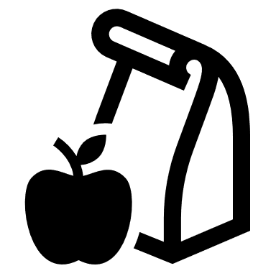 **Lunch Box Traces**

Name: _________________________________________

**Choose 1 item from your lunch box. Draw and label it here:**

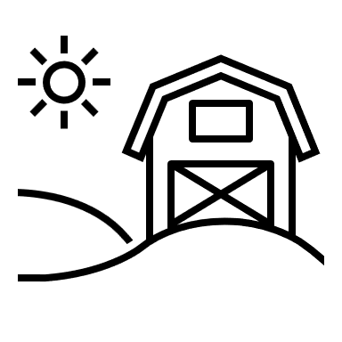

**Can you trace it back to a local food source?**

Where did you get it from first?

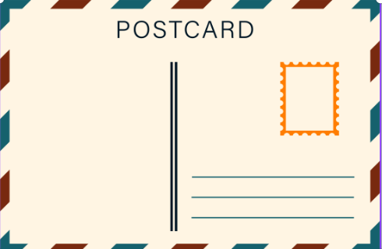

Fold here

