Earth Day Actions

Want to DO something to impact the world around you? Choose from a variety of activities this Earth Day, and every day, to truly make a difference!
- Read Another Earth Day Book:
Grab another great read aloud from your own stash or read one of these titles via SORA (free for NB educators: https://soraapp.com ) to display on your Smart Board or projector:
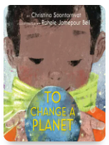  To Change A Planet  By: Christina Soontornvat | 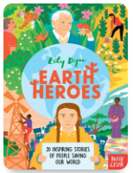  Earth Heroes  By: Lily Dyu | 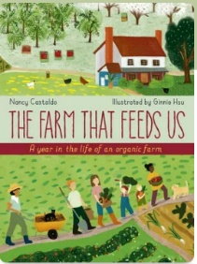  The Farm That Feeds Us  By: Nancy Castaldo | 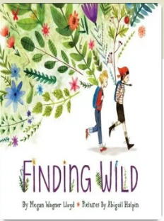  Finding Wild  By: Megan Wagner Lloyd
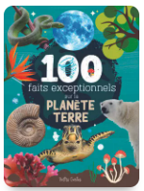  100 faits exceptionnels sur la planète Terre  Par: Mathieu Fortin | 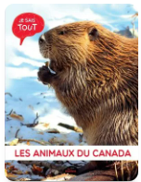  Les Animaux du Canada  Par: Jessica Lupien | 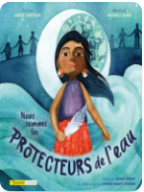  Nous Sommes les protecteurs de l’eau  Par: Carole Lindstrom | 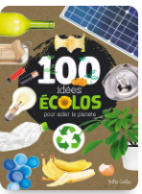  100 idées écolos pour aider la planète  Par: Valérie Menard

- Create Earth Day Raps with Beastbox:
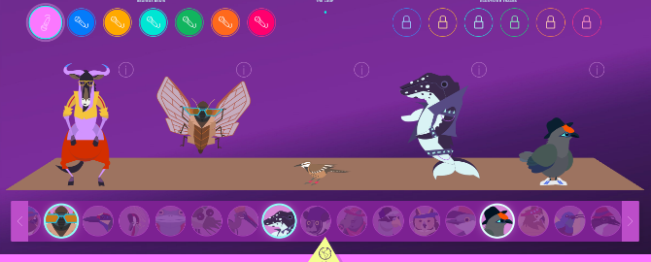
The Cornell Lab of Ornithology has teamed up with wildlife DJ and beatboxer, Ben Mirin, to present Beastbox. This website (it can also be used on a Smart Board, iPad, laptop, etc.) gives students the opportunity to mix real-life wild animal voices with beatbox loops. Tie in with April’s Poetry month and have students write 4 or 8 lines all about Earth Day to accompany their chosen track. Students can perform for their peers! https://academy.allaboutbirds.org/features/beastbox/
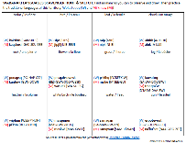
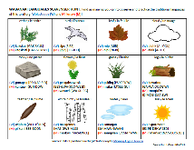
- Complete a Wabanaki Languages Outdoor Scavenger Hunt:
Individually or in small groups, have students find as many items on the list that they can while also practicing the traditional languages of Wolastoqey and Mi’kmaw. Choose from two scavenger hunts that were created by Elder Opolahsomuwehs (Wolastoqewiyik) and Janelle LeBlanc (ASD-S) in the Appendix.

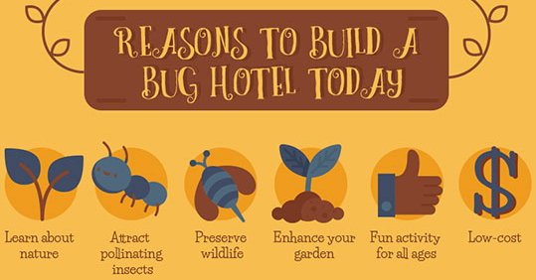
- Build Insect Hotels for Your Outdoor Spaces:
Bug hotels are all-natural structures made from plant material that provide shelter for common garden insects and creatures. Check out this wonderful infographic from Capital Garden Services explaining the items needed, as well as the instructions for building your own bug hotel!
https://www.natureconservancy.ca/assets/images/blog/how-to-build-a-bug-hotel-infographic-capital-garden-services-custom.jpg
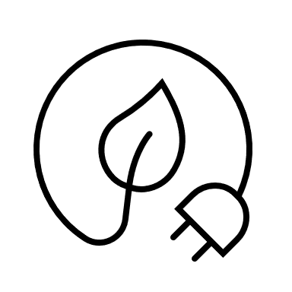
- Plan 1 hour of your day with NO lights and NO electronics:
Be strategic and commit to saving energy for 1 hour of the school day! Be sure to look over the schedule and have students share when they think a great time would be to do this. If possible, why not go for more than 1 hour? Just be sure to create a sign on your classroom door for anyone passing by – it may catch on!

- Create Classroom Signs to Save Energy & Water:
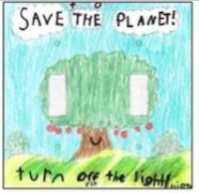
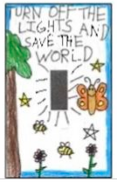
On Earth Day, it may be easy to remember to do the little things in the classroom to save energy and water. Using white paper, have students create reminders around sink faucets, technology stations, light switches, the Smart Board, and larger electronics to save energy everyday. Students can create these individually or in small groups. With permission, create signs for hallways, bathrooms, and other school rooms.

- Lunch Box Traces:
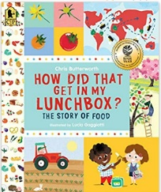
Have students choose 1 item from their lunch box (or hot lunch order). Using the printable in the appendix, have students draw their item and see if they can trace it back to a local food source (farm, farmer’s market, bakery, etc.)? Discuss why locally grown food helps the environment. Name local farms near your school – what do they grow? Feel free to use these sources to help look up local food traces, farms, and farmer’s markets:
Read: How Did That Get In My Lunchbox? By: Chris Butterworth (available on Sora)
Agriculture in the Classroom NB: https://www.aitc-aec-nb.ca/farmer-contact-list
New Brunswick Farmer’s Markets: https://www.farms.com/rural-lifestyle/farmers-markets/new-brunswick.aspx
Eating locally grown food impacts the environment in many positive ways: it doesn’t need to be transported (reduces greenhouse gas emissions), it has passed some of the highest food safety standards (regarding additives, pesticides, herbicides, etc.), it may have a higher nutrient value (may be given more time to ripen), less waste and packaging, and it benefits the local economy.
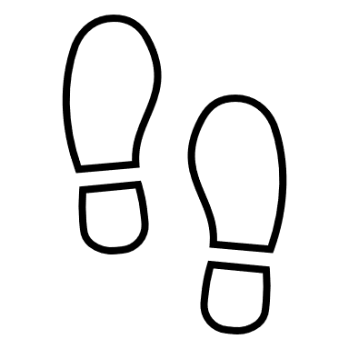
- Go on a Human Impact Walk:
For this walk, plan a route where the impact of human activity is clearly visible (e.g: an industrial area, by or through a shopping mall, or even a well-used trail in the woods or a park). Ask students to imagine what the place might be like if people had never been there. What might be here that isn’t? What is here now that might not be? How might the land have looked 50 years ago? A hundred? A thousand? How might we reduce our impact on the area now or restore features that have been lost? Students can complete writing or drawing exercises imagining what the area looked like in the past and envisioning what it might look like in another hundred years if the human impact continues.
Excerpt from: A Walking Curriculum: Walking, Wonder, & Sense of Place (K-12) by: Gillian Judson, pg.43-44.
- Have a Picnic Lunch Outside (if weather permits):
Whether on blankets, picnic benches, or grassy areas, enjoy eating outside. For younger classes, why not have a teddy bear picnic and invite students to bring their favourite stuffed animal to attend, as well.
- Try a Recycled Art Project with Recyclables Saved Up:
Using the recycling bin in your classroom OR by asking students to bring in 1 recyclable item from home, create recycled art to showcase in your school. Here are some ideas, but feel free to try one of your own:
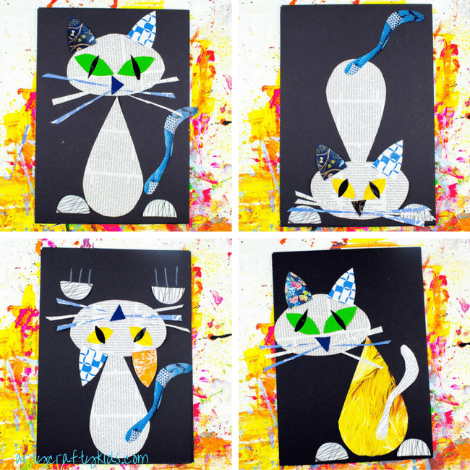  Recycled Paper  Using a variety of recycled papers, create a variety of cat poses.  https://www.artycraftykids.com/art/cool-cat-newspaper-art-project-for-kids/ | 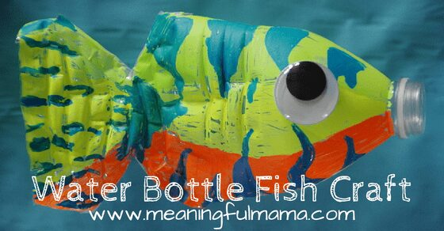  Recycled Water Bottles  Create a display to bring awareness of the plastic in our oceans and the impact it is having on our sea creatures.  https://meaningfulmama.com/water-bottle-fish-craft.html | Recycled Cardboard  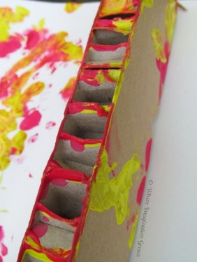  Try printmaking using recycled cardboard and paint.  https://www.whereimaginationgrows.com/printmaking-recycled-cardboard-art/
- Organize a School Grounds Clean-Up:
Take a few garbage bags outside and divide up areas on your school grounds to pick up litter. Is there one area with more garbage than the rest? Discuss a solution! (Signs, announcements, an extra garbage can, a recycling container, etc.)

- Play, “Who Am I?” Game by CPAWS (Canadian Parks and Wilderness Society) to Identify New Brunswick animals:
*English version only: https://cpawsnb.org/wp-content/uploads/2020/04/Who-Am-I-Game-with-CPAWSNB-b.pdf
*French, English and Mi’kmaq language New Brunswick Animals Colouring Book Printables: https://cpawsnb.org/wp-content/uploads/2021/05/Kayla-Mutch-Colouring-book-Challenge-Submission.pdf

- Write a letter/email to Honourable Gary Crossman, New Brunswick Minister of Environment and Climate Change:
Using the template provided in the Appendix, have students write to the New Brunswick Minister of Environment and Climate Change individually or a as a class. Have them put their ideas down on paper on how New Brunswick can address Climate Change. For a class writing activity, you may also choose to email him a group letter. Find Honourable Gary Crossman on the Legislative Assembly of New Brunswick website at: https://legnb.ca/en/members/current/20/crossman-gary .
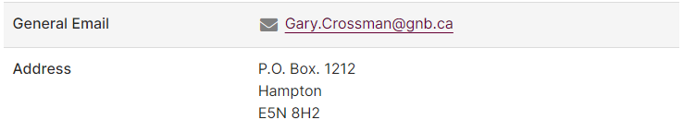
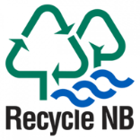
- Watch NB Recycle talk about recycling and Create Posters:
After viewing one or more videos from Recycle NB, have students create posters (on white paper) to bring awareness to items that are being recycled and repurposed, but might not be known to the general population.
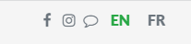
Videos: https://www.recyclenb.com/videos (available in both French and English – choose language preference at the top of the webpage.)

- Identify Renewable and Non-Renewable energy sources in NB:
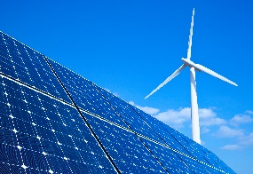
Atlantica Centre for Energy has created an interactive map highlighting all of NB’s Energy resources: New Brunswick’s Energy Resources – Atlantica Centre For Energy (atlanticaenergy.org) Discuss what the difference is between renewable and non-renewable energy sources. How will this impact New Brunswick in the future?
For additional information on Renewable Energy see:
English - CER – Canada's Renewable Power – New Brunswick (cer-rec.gc.ca)
French - REC – L’électricité renouvelable au Canada – Nouveau-Brunswick (cer-rec.gc.ca)
- Play Outside and simply ENJOY!

- Go on a WORLD Adventure in your classroom:
Choose an adventure below to explore the four corners of our amazing EARTH:
Climb Mt. Everest - Street View Treks: Everest Base Camp – About – Google Maps
Swim Through a Coral Reef - David Attenborough's Great Barrier Reef | Explore (attenboroughsreef.com)
Virtual Trip to Antarctica - Virtual trip to Antarctica - British Antarctic Survey (bas.ac.uk)
Explore the Secrets of Ancient Ruins - Experience Machu Picchu in Virtual Reality. (youvisit.com)
LIVE CAMS – Northern Lights and Animals from Around the World - Northern Lights Live Cam - watch the Aurora Borealis | Explore.org
- Take Macro Photographs of Nature for Your Own Art Gallery:
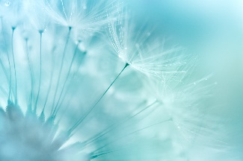
Using iPads or available cameras, have students in small groups take a walk on the school grounds and take a photograph of a natural item up-close (e.g: flower, blade of grass, insect, tree bark). Feel free to print in black or white (or colour, if available) and display them. Even have students try to guess what the natural is as a “guessing game”. Discuss the details of these natural items that a photograph captures but not always our eye sees.

- Plan a Litterless Snack for Morning Recess:
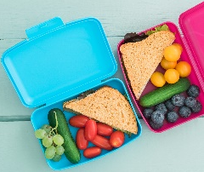
Understanding that not every student may be able to participate, give students ideas on what a litterless snack can be and encourage most to participate. Examples: any food item in small containers or cloth/reusable baggies.
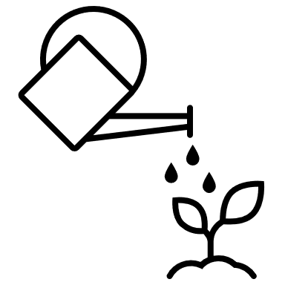
- Plant a Tree or Flower Seeds in your Outdoor Spaces:
If you are looking for free flower seeds, email NB Nature for free milkweed seeds (a native plant and important for our Monarch Butterfly population): Milkweed Seeds for Monarchs | Nature NB

- Go PAPERLESS today in all Classroom Activities:
This one may mean being very selective in the other activities that you choose on the BINGO grid. Instead of printing paper activities, have students come up with ideas on how NOT to use paper this day while still keeping most of your regular routines in place.
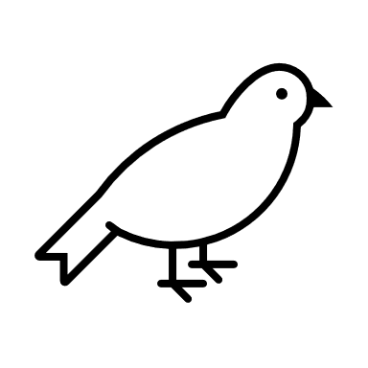
- Build Bird Feeders for your Outdoor Spaces:
Get creative! Check out these ideas for DIY bird feeders: 25+ Popular Easy DIY Bird Feeders You Need to Make With The Kids - This Tiny Blue House
Check out which birds we have here in New Brunswick: New Brunswick, CA · iNaturalist Canada

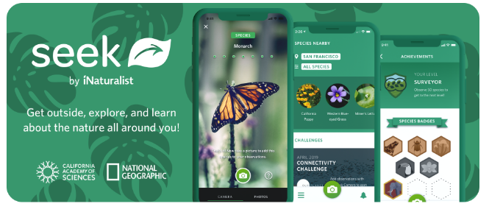
- ID Plants & Trees in your School’s Outdoor Space with the Seek app:
Free in the App Store and available in district catalogues (with iPad requests), Seek allows students to take a photograph of a plant or animal outside, and then gives them information on that species, using image recognition technology. https://www.inaturalist.org/pages/seek_app

- Plan and DO an Action Item that YOU create as a Class:
The possibilities are endless! Already part of an environmental project? Count that, too! We also recognize that there may be a specific act that you and your students would want to do that would directly impact your classroom, school, or community.

Acknowledgements:
Cornell University, Bird Academy: Beastbox – https://academy.allaboutbirds.org/features/beastbox/
Capital Garden Services, How to Build A Bug Hotel Infographic, 2018 – https://www.capitalgardenservices.ie/blog/how-to-make-a-bug-hotel/
Victoria News, 2022: Greater Victoria students create art to promote energy conservation - https://www.vicnews.com/community/greater-victoria-students-create-art-to-promote-energy-conservation/
McGill University, 2023: The benefits of eating local foods – https://www.mcgill.ca/foodservices/sustainability/green/local#:~:text=It's%20good%20for%20the%20environment,local%20farmers%20and%20other%20producers.
Judson, Gillian: Human Impact Walk - A Walking Curriculum: Walking, Wonder, & Sense of Place (K-12), 2018, pg.43-44.
Meaningful Mama: Water Bottle Fish Craft, https://meaningfulmama.com/water-bottle-fish-craft.html
Arty Crafty Kids: Cool Cat Newspaper Art Project for Kids, 2021 - https://www.artycraftykids.com/art/cool-cat-newspaper-art-project-for-kids/
Where Imagination Grows: Printmaking with Recycled Cardboard, 2014 - https://www.whereimaginationgrows.com/printmaking-recycled-cardboard-art/
CPAWS – Kids- At Home Activities, https://cpawsnb.org/campaigns/kids/
Recycle NB : Videos, 2023 - https://www.recyclenb.com/videos
Atlantica Centre for Energy : Canada Energy Regulator, 2022 CER – Canada's Renewable Power – New Brunswick (cer-rec.gc.ca)
Prodigy Game: 20 Fun Earth Day Activities for Kids to Help the Planet, 2021 - 20 Fun Earth Day Activities for Kids to Help the Planet | Prodigy Education (prodigygame.com)
Nature NB: Milkweed Seeds for Monarchs, 2023 - Milkweed Seeds for Monarchs | Nature NB
Tiny Blue House: 25+ Popular Easy DIY Bird Feeders You Need To Make With The Kids, 2022 - 25+ Popular Easy DIY Bird Feeders You Need to Make With The Kids - This Tiny Blue House
iNaturalist Network: New Brunswick - New Brunswick, CA · iNaturalist Canada
iNaturalist Network: Seek by iNaturalist, 2021 - Seek by iNaturalist · iNaturalist

Cross-Curricular Outcomes:
Literacy | GCO 1: Students will speak and listen to explore, extend, clarify, and reflect on their  thoughts, ideas, feelings, and experiences.  GCO 2: Students will be able to communicate information and ideas effectively and  clearly, and to respond personally and critically.  GCO 5: Students will be expected to interpret, select, and combine information using a variety of strategies, resources, and technologies.  GCO 8: Students will be expected to use writing and other forms of representation to explore, clarify, and reflect on their thoughts, feelings, experiences, and learnings; and to use their imaginations.
Math | Concepts and Content: counting, number sense, and time
Visual Arts & Music | GCO 1: Students will explore, challenge, develop, and express ideas, using the skills, language, techniques, and processes of the arts.  GCO 2: Students will be expected to create and/or present, collaboratively, and independently, expressive products in the arts for a range of audiences and purposes.
Science | SCO 2.1 -Students will consider factors that support responsible application of scientific and technological knowledge and demonstrate an understanding of sustainable practices.  Concepts and Content:  Grade 3 – Climate, Habitats, Plants, Animals  Grade 4 – Uses of Earth’s Resources  Grade 5 – Effect of environmental and physical factors on maintaining a healthy and functional body
Social Studies | 3.1.2 Describe the major physical features, climates, and vegetation of their province and the Atlantic region  4.3.1 Examine major physical features of the world  4.3.3 Examine the relationship between humans and the physical environment.
You and Your World | K 4.1 describe and locate some of the natural and constructed features of their community  1.2.1 describe how plants and animals meet their needs in a given environment.  1.2.2 plan and conduct investigations that explore similarities and differences between plants and animals.  1.2.5 describe how people depend upon and interact with different natural environments; and  1.2.6 take age-appropriate action to practice responsible behaviour in caring for the environment.  2.5.3 describe how people’s interactions with the environment have changed over time; and  2.5.4 demonstrate an understanding of sustainable development and its importance to the future.
Global Competencies:
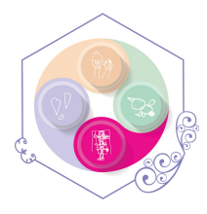 | 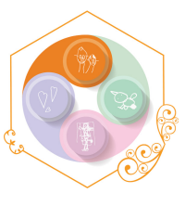 | 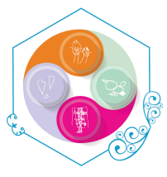 | 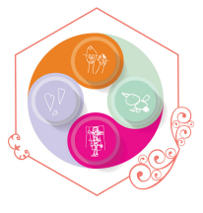 | 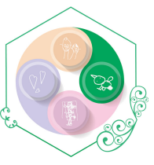 | 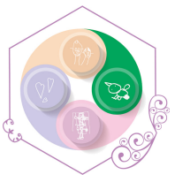
Collaboration | Communication | Critical Thinking & Problem-Solving | Innovation, Creativity & Entrepreneurship | Fostering and Teaching Self-Awareness and Self-Management | Sustainability and Global Citizenship
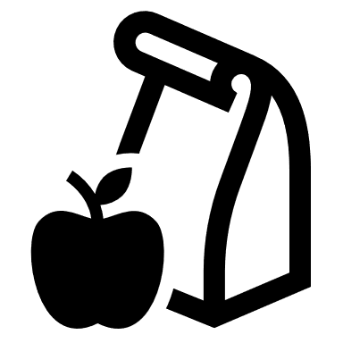
Lunch Box Traces
Name: _________________________________________

Choose 1 item from your lunch box. Draw and label it here:

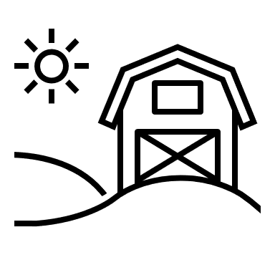
Can you trace it back to a local food source?
Where did you get it from first?

Traces Dans La Boîte à Lunch
Nom: _________________________________________

Choisissez 1 aliment dans ta boîte à lunch. Dessinez-le ici:

Pouvez-vous trouver des traces de sources locales?

D'où l'avez-vous obtenu en premier?

______________________
______________________
______________________
______________________

__________________________________,
______________________________________________________________________________________________________________________________________________________________________________________________________________________________________________________________________________________________________________________________________________________________________________________________________________________________________________________________________________________________________________________________________________________________________________________________________________________________________________________________________________________________________________________________________________________________________________________________________________________________________________________________________________________________________________________________________________________________________________________________________________________________________________________________________________________________________________________________________________
__________________________________,
__________________________________
