Overview

Wind Energy ChaLLENGEF

Updated 2024

The Wind Energy Challenge is based upon the [KidWind Challenge](https://www.kidwind.org/online-challenge). Students are provided with materials to design and build their own wind turbine. The goal is to generate the greatest amount of energy possible. Students can iterate with the number of blades, shape, size, position, materials and pitch.

In addition to this hands-on engineering design project, students are provided with information on the electricity grid and wind energy production courtesy of [The Gaia Project](https://thegaiaproject.ca/en/).

Materials

The kit comes with the PVC stand, generator, dowels, hub and a multimeter to measure output. It is recommended that students start with low-cost materials like cardboard or cereal boxes. Additional materials needed for this activity are a household fan and tape/glue.

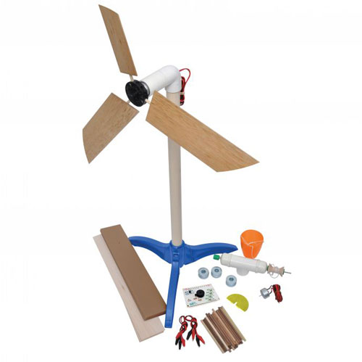

The turbine can be modified by adding an advanced wind kit gearbox to the top of the tower or by replacing the hub with a spool and string to allow the students to determine how much weight can be lifted by their blade design (not included in the basic kit).

Instructions

1. Provide an introduction to renewable energy.  This could be done by showing the following [video](https://vimeo.com/131459986) or arranging a presentation on wind energy from [**The Gaia Project**](https://thegaiaproject.ca/en/).
2. Next, lay out the challenge by displaying the wind turbine stand set-up (see picture above).  Let students know that their job is to design and build the blades for the wind turbine.  The goal is to make the turbine generate the greatest amount of electricity by spinning as fast as possible.  The students must determine the number, materials, shape, size and pitch of their blades.
3. Distribute the [Wind Turbine Design and Testing Sheet](http://eecd-coe-energy.transformationnb.ca/wp-content/uploads/2021/08/Wind-Turbine-Design-and-Testing-Sheet.pdf) to the students.  Designs must be completed by the students before they receive the building materials.
4. Once initial designs are approved, distribute the hubs, dowels and building materials to the students. Provide time for students to assemble their blades.
5. Once blades are constructed and attached to the hub, students must now test their designs by attaching the hub to the generator at the top of the wind turbine.  Turn on the fan and record the output of their blades using the multimeter.
6. Students should next iterate their designs in order to create the greatest amount of energy.  Encourage students to start their iterations by adjusting the pitch (angle) of the blades first before altering the blade number, shape, size, etc.

Advanced Designing

Students may also want to build their own turbines from scratch. Students can start by building their own base and tower then graduate to gears or belt-drives and even building their own generator! There are many designs and tips that can be found online.

Resources

Check out the following resources for more ideas and inspiration.

[Wind Power in New Brunswick](https://www.nbpower.com/en/about-us/our-energy/wind-energy)

[Wind Energy Technologies Office | Department of Energy](https://www.energy.gov/eere/wind/wind-energy-technologies-office)

[WINDExchange: Wind for Schools Project (energy.gov)](https://windexchange.energy.gov/k12)

[Wind | NREL](https://www.nrel.gov/wind/index.html)

[Understanding Winds: The Atmosphere in Motion (thoughtco.com)](https://www.thoughtco.com/understanding-winds-3444496#:~:text=Understanding%20Winds%201%20The%20Pressure%20Gradient%20Force.%20It%27s,5%20Wind%20Scales.%20...%206%20Wind%20Terminology.%20)

[Wind Power Animation](https://interactives.ck12.org/simulations/physics/wind-turbine/app/index.html)

Sponsors

The wind challenge would not be possible without the support of the following organizations:

