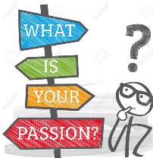
Idea Generator

Step 1: Watch Emilie Wapnick Ted Talk- https://www.youtube.com/watch?v=4sZdcB6bjI8

Step 2: List at a minimum 5 things that you like/love in your life. Choose three to write a short memory as to why you like/love these things.

Step 3: Next, ask yourself these questions: These questions are meant to help you identify the activities that make you light up—the things you love to do more than anything else. These questions will help you zero in on them.

- When I was a kid I dreamed of……..
- I love books, movies, or T.V. shows about…….
- If I had a week off school and could do whatever I want, I would………
- Most people don’t know this about me, but I really enjoy………
- I am the go-to person when my friends need help with…………
- If I could star in my own how-to TV show it would be about……….
- If I were to make a homemade gift it would involve……….
- I’ve tried it only once or twice, but I really enjoy……….
- I get most excited about…….
- If I won first prize in a talent show it would be for………

Your Passion Roadmap
Step 4: Create a Wishlist to help you define your values and goals. Think as big or small as you want! Use the following sentence to get you started. If I could do anything, be anything, or have anything, what would it be?

Today:

3 Months from now:

1 Year from now:

3 Years from now:

Lifetime goals:

Step 5: Now look at all three lists. What Are the similarities? Choose at least three that are most important to you. Try to picture your life doing only those activities. What would those activities be?

Top 5 Things:
1)
2)
3)
4)
5)

