From Mystery to Must-Have!
A Cross-Curricular Learning Activity for K-2

Overview
Entrepreneurs have incredible creativity and unique perspective – they can turn an everyday, ordinary object and turn it into a product that no one thought of before. In this activity, stretch your students’ creativity as they take a random mystery object and transform it into a must-have item for customers - just like a real entrepreneur!

What you’ll need

- PowerPoint Presentation (attached)  - 1 toothpick  - Read Aloud: Not A Stick (by: Antoinette Portis)  - A Must-Have Item Planning printable sheet (attached)  - Pencils | - A variety of random objects in a reusable bag for students to choose (ex: brush, spatula, bowl, pencil holder, maraca)  - Recyclable materials (cardboard boxes, paper, newspaper, rubber bands, paperclips etc.) - optional

Instructions
1. DISCUSSION: Gather students together and ask: “What is an entrepreneur?” Allow students to share their responses. An entrepreneur is a person who starts a business with great risk. Then, have students share what type of person starts something new (examples: risk taker, thinker, knows what people need/want, organized, smart with money, etc.). “Are there entrepreneurs in our community?” Allow students to share new businesses that have launched near them.

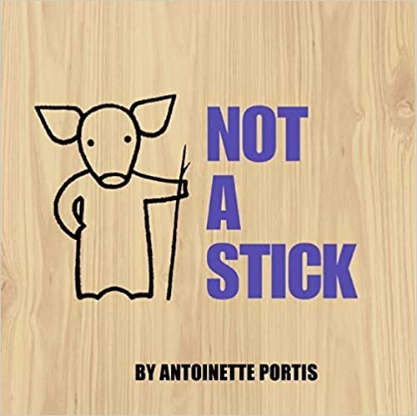
2. CIRCLE GAME & READ ALOUD: Gather students together in a circle. Show them 1 toothpick and tell them the object of the game: “We are going to pass around this small piece of wood, BUT it’s NOT a toothpick! I want you to be as creative, crazy, and give us another use for this object. I’ll go first – This is NOT a toothpick, it’s a mouse’s sword!” Pass the toothpick around the circle (allowing students to pass if desired) and share their NEW idea. After every learner has had a turn, read “Not A Stick” (by: Antoinette Portis). After reading, see if any ideas were the same, even though the stick is a little bigger in the story.

3. POWERPOINT ACTIVITY: One characteristic of an entrepreneur is also having a good “eye”. Entrepreneurs can often see things that others may miss. Do YOU have an “entrepreneurial eye”? Using the PowerPoint slides 2-5, look at the given objects and see if students can also “see” another use for that item. Using the arrow buttons, reveal what the inventors originally made the products for – then an entrepreneur saw something else and that’s how we know about them today! Talk about if your guesses were close.

4. MYSTERY ITEM ACTIVITY: Allow students the option to work individually, in pairs or small groups of 3. Have a variety of mystery items (that cannot be seen ahead of time) available so that each group can use 1. Students will use their mystery item, along with their planning printable sheet (below and on Slide 6) and recyclable materials to turn it into a NEW must-have product headed to local stores! (Note: students can add recyclable items to their mystery item ONLY if it does not destroy or compromise the item – no glue, no cutting the item, etc.).

After 20-25 minutes, have students share their creative NEW must-have product with the class, showcasing what it was before and describing what it is now!

5. REFLECTION: Gather as a group to discuss the following questions:
- Was it challenging creating something new from not a new object?
- What would you do differently next time if you were given another mystery object to transform?
- What did you learn about being an entrepreneur that you didn’t know before today?
- Could you see yourself being an entrepreneur?
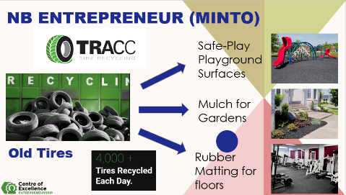
6. CAREER CONNECTIONS: Looking at Slide 7 of the PowerPoint Presentation, discuss as a class how entrepreneurs at TRACC Tire Recycling in Minto “saw” old tires. Feel free to visit their website: https://www.tracc.ca/ on more products that they are making. Discuss: “Are there other items, like old tires, that we can re-use or see new purpose in? How might this help our school, our community, and our world?”

Possible Extensions
- Set up a NOT a __________! station with a basket of objects and the printable provided in your classroom. Keep the creativity going for students and allow them to transform everyday objects into new products!
- Host an entrepreneurial showcase in your classroom, displaying your NEW must-have objects and having students share their innovations with another classes.
- In Math, using 2D and 3D shapes, have students practice their math vocabulary while also coming up with new ideas for spheres, rectangular prisms, pyramids, squares, and triangles (and more!). Ex: This is not a sphere, it’s a small alien planet!
- Decide on a repurposed project (talk about what you are recycling and throwing out a lot of as a class – could some of these items be repurposed or re-used?) Come up with a way to reduce or reuse in your own classroom, using your entrepreneurial eye!
- Set up a guest entrepreneur speaker to come to your class or a field trip to a local entrepreneurial business. Needing help with this, reach out to the Centre of Excellence for Entrepreneurship via email: nbcoe@gnb.ca.
Additional Read Alouds
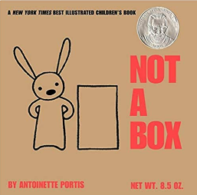 | 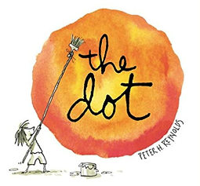 | 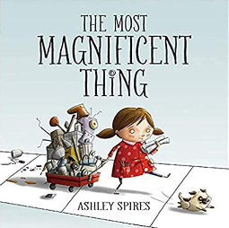
Not A Box  By: Antoinette Portis | The Dot  By: Peter H. Reynolds | The Most Magnificent Thing  By: Ashley Spires

NB Cross-Curricular Outcomes
You and Your World | K 3.2 use one or more of their senses to explore the characteristics of materials, noting how materials can  be manipulated  1.4.1 demonstrate an understanding that the way people live in their community evolves over time  2.3.1 appreciate the changing nature of work
Literacy | GCO 1: Students will speak and listen to explore, extend, clarify, and reflect on their  thoughts, ideas, feelings, and experiences.  GCO 2: Students will be able to communicate information and ideas effectively and  clearly, and to respond personally and critically.  GCO 8. Students will be expected to use writing and other forms of representation to explore, clarify, and reflect on their thoughts, feelings, experiences, and learnings; and to use their imaginations

NB Career Education Framework
Thinking about my potential future in work | K-2  I can tell you about some of the different jobs that people do and whether I would like to do them.  I could do any job I want when I am older.

NB Global Competencies
 | 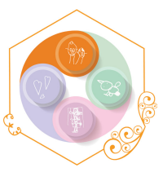 | 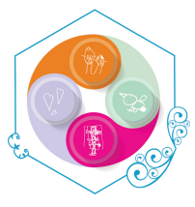 | 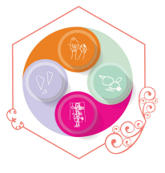 | 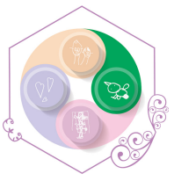
Collaboration | Communication | Critical Thinking & Problem-Solving | Innovation, Creativity & Entrepreneurship | Sustainability and Global Citizenship

Acknowledgements

1. 11 famous products that were originally intended for a completely different purpose, Insider Magazine, April 2016, Will Heilpern - https://www.businessinsider.com/successful-products-that-were-originally-intended-for-a-completely-different-purpose-2016-3.
2. TRACC Tire Recycling, 2019 - https://www.tracc.ca/ .

Our NEW Must-Have Item PLANNING SHEET

Name(s): ____________________________________________________________________
Draw and write details about your item…
Before: After:

Why MUST customers buy your NEW item?
____________________________________________________________________________________________________________________________________________________________

