Random Acts of Kindness & Stan the Man’s Bookmobile –
Response Sheet
Think about it… then write about it! Did you notice the author repeated the word “kind” three times? Circle each “kind” found in the quote below.
Next, set 2 minutes on the clock and write your thoughts: In your opinion, why would the author use “kind” three times? Rewrite the quote, BUT list three important things to you where the author used the word “kind.” Or what is the meaning of this quote to you?
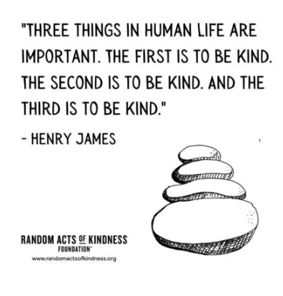
______________________________________________________________________
______________________________________________________________________
______________________________________________________________________
______________________________________________________________________
______________________________________________________________________
______________________________________________________________________
______________________________________________________________________
___________________________________________________________________________________________________

Brainstorm It: In the thought bubble below, list ways to show kindness to others. Draw or list words/phrases, actions, etc.

Think, Pair, Share It: Meet with a classmate or small group to share your answers. Add to your list any great ideas mentioned by classmates.
Predict It & Question It: Using only the title of our shared text…

At Stan the Man’s Bookmobile, Kids Buy Books with Acts of Kindness
- Make two predictions – What might this text be about?
- List two questions you’re left with, ones you hope will be answered during your reading.
Prediction #1: ____________________________________________________________________________________________________
Prediction #2: ____________________________________________________________________________________________________
Question #1: ______________________________________________________________________________________________________
Question #2: ______________________________________________________________________________________________________

Read It & Summarize It: Before you read the article from Newsela, skim through it. Each section below matches the sections in the article. Summarize each section with a few main ideas.
Introduction A Rising Tide of Kindness

“It’s Cool to Be Kind” The Birth of “Stan The Man”

Create It: As a class, examine the Random Acts of Kindness Calendar for the 2021-2022 school year.
https://www.randomactsofkindness.org/for-educators
- What about if classes in your school designed a RAOK calendar for YOUR SCHOOL or each CLASS?
- What types of themes might be generated each month to include all students?
- In September consider how can you make new students feel welcomed?
- Or what types of events could be held to show appreciation for teachers, custodians, Educational Assistants, counsellors, bus drivers, parents, cafeteria staff, librarians, coaches, principal or vice principals, volunteers, Administrative Assistants, etc.
- Consider expanding your focus to people or groups in your community who would benefit from your kindness. How might you connect with local seniors, immigrants, local charities, non-profit groups, etc.?
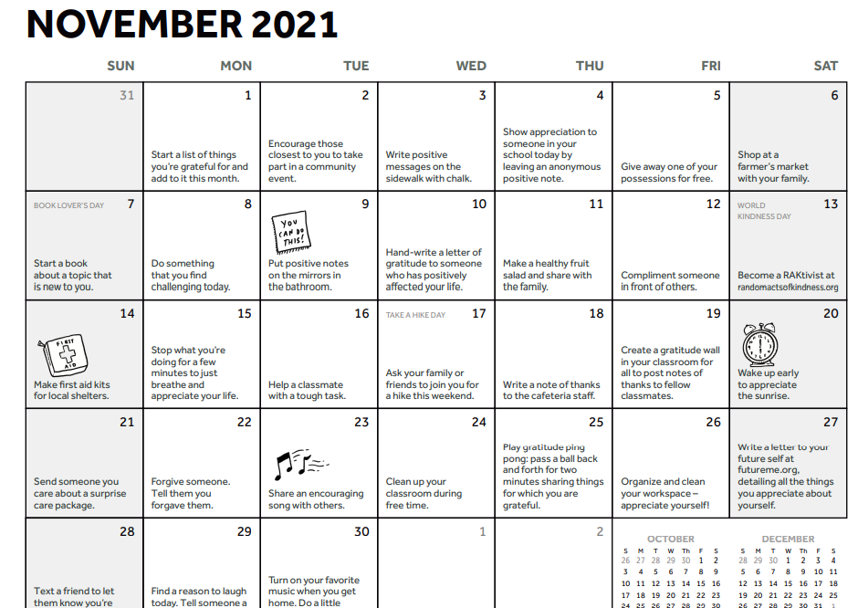
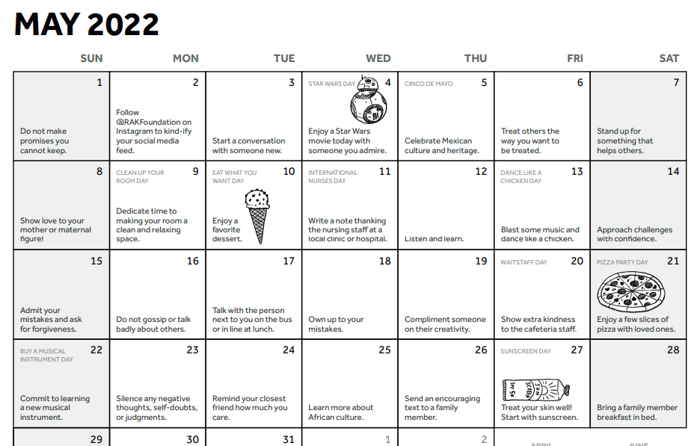
- The goal is not to spend money; it’s to spread kindness! Use your answers from the Brainstorm It section and create a one-month calendar page for your classroom or for each individual student.

