***, Picture

**Overview**

Students will explore the importance of oral hygiene while discovering the exciting world of dentistry. Through discussions, storytelling, and hands-on activities, students will learn what dentists do, the tools they use, and how they help keep our smiles bright and healthy. The activity includes building clay teeth, getting them "dirty" on a scavenger hunt, and using creative classroom "dentist tools" to clean them again!

**NB Curricular Connections**

|  |
| --- |
| Explore Your World:   * *Strand:* Play and Playfulness. *Big Idea:* Imagination and Creativity – *Skill Descriptor:* Practise using flexible and fluid thinking in new and familiar situations. *Skill Descriptor:* Examine new possibilities. Skill Descriptor**:** Examine new activities, interests, and possibilities. * *Strand:* Well-Being. *Big Idea:* Physical Health and Active Participation *Skill Descriptor:* Analyze personal safety and healthy practices. |
| English Language Arts:   * *Strand:* Interactions – *Big Idea:* Expression – *Skill Descriptor:* Express feelings and opinions and give simple descriptions of experiences. * *Strand:* Reading – *Big Idea:* Reading Comprehension – *Skill Descriptor:* Construct meaning from oral stories, read-alouds, and text. * *Strand:* Reading – *Big Idea:* Exchanges. Skill Descriptor: Give and follow simple, one- or two-step directions or instructions. Skill Descriptor: Respond personally to presentations, oral stories, and multimodal text. |

**What You’ll Need**

|  |  |
| --- | --- |
| * Clay or Playdough * String (dental floss) * Toothpicks (explorers) * Pencils (scalers) * Mirror * Sponge (polisher) * Spray bottle (water flosser) |  |

**Instructions**

(*Also available in Canva slide presentation*)

1. **Class Discussion**
   * What do dentists do? Who’s visited one before? What happened?
   * Think-pair-share: Share your experience with a classmate.
2. **Read-Aloud Time**
   * Read *What Makes a Community: Dentists* (available on SORA).
3. **Build Your Teeth**
   * Give each student clay or playdough.
   * Create a semi-circle base.

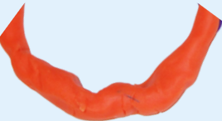

* + Make and place/lodge 10 teeth into the base (use different colored clay if possible).

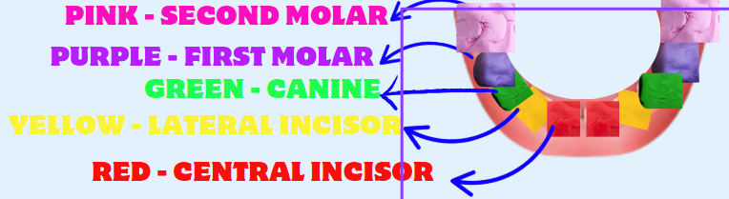

*Teaching the names of teeth is optional.

* + *Fun Fact:* Kids have 20 baby teeth; adults have 32 permanent teeth.

1. **Plaque Scavenger Hunt**

Students will simulate how teeth get “dirty” by going on a Plaque Scavenger Hunt around the classroom.

**How it Works:**

Students will search the classroom for small, safe items. Students will use teacher-approved materials such as:

* Paper scraps
* Glitter
* Crumbs
* Chalk dust or bits
* String, beads, or other tiny craft items

These materials represent **plaque**, the sticky film of bacteria that can build up on real teeth after eating or drinking. The goal is to show students how easy it is for “plaque” to collect on teeth—and how important it is to clean it off regularly. By placing these materials on their clay teeth models, students will be able to *see* and *feel* the challenge of cleaning teeth, just like a real dentist does.

1. **Dentist Time!**

Now that our clay teeth are nice and messy with "plaque" from the scavenger hunt, it’s time to learn how dentists clean and care for our teeth!

* Start with a class discussion:

Think about when you go to the dentist. What tools do you remember seeing? What sounds do you hear? What do those tools do?”

Next, show slides 15/16 on the Canva slide presentation (or see below) to show real dental tools and explain what each one does.

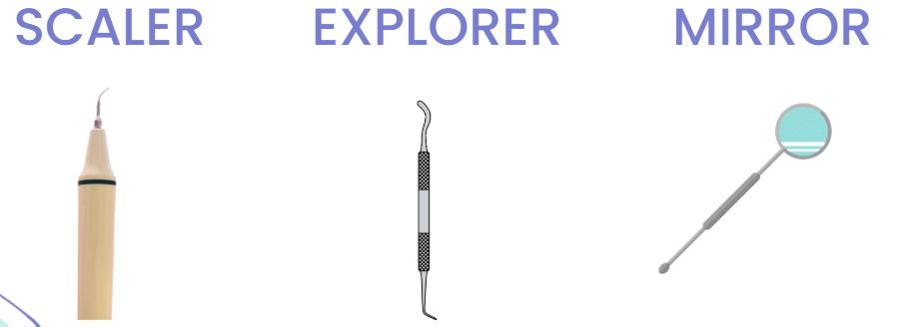

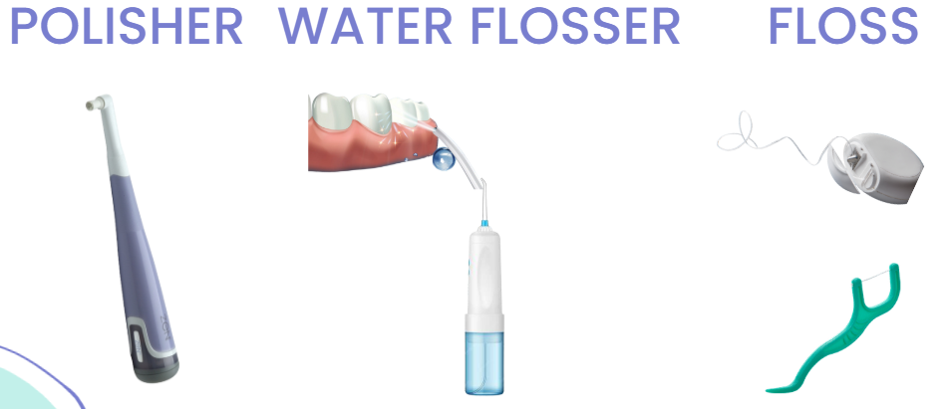

Then, introduce the **classroom versions** students will be using at the cleaning stations. Here’s how they compare:

| **Real Dental Tool** | **Purpose** | **Classroom Equivalent** |
| --- | --- | --- |
| **Mirror** | Helps the dentist see hard-to-reach areas in your mouth | Small mirror |
| **Explorer** | Used to check for cavities or soft spots | Toothpick |
| **Scaler** | Scrapes off plaque and tartar | Pencil (gently!) |
| **Polisher** | Smooths and shines the tooth surface | Sponge |
| **Dental Floss** | Cleans between teeth | Piece of string |
| **Water Flosser** | Blasts away food and plaque with water | Spray bottle |

1. **Dental Centers Rotation**  
   Students will rotate through six interactive “dentist tool” stations, each designed to mimic a real tool or technique used by dentists. At each station, they will use imaginative, hands-on materials to clean their clay teeth, simulating the process of removing plaque, polishing surfaces, and inspecting for cavities. From using toothbrushes and floss to magnifying glasses and pretend dental mirrors, students will experience the fun and challenge of being a dentist—while reinforcing the importance of good oral hygiene in a playful way.

Centers:

Toothpick (explorer)

Pencil (scaler)

String (floss)

Sponge (polisher)

Spray Bottle (water flosser)

Mirror

**Reflection Questions:**

* What tool worked best to clean your teeth?
* Why do you think dentists use different tools?
* Did any teeth get loose or break?
* Why is it important to take good care of your teeth?

**Extension Activities**

Watch: *A Visit to the Dentist – Catie’s Classroom*

[**A Visit To The Dentist | Caitie's Classroom Field Trip | First Dental Visit Video for Kids**](https://www.youtube.com/watch?v=70loZVsvaqM)

* + Compare Catie’s experience with yours. What was the same? What was different?

Count your clay teeth – do you have all 20?

Explore: *My Wiggly Tooth* learning activity (Centres of Excellence for Health)

**Reflection Activity**

Please see the attached PDF for several choices on how you and your learners can reflect upon today’s activity.

**Global Competencies**

|  |  |  |  |  |
| --- | --- | --- | --- | --- |
|  |  |  |  |  |
| **Collaboration** | **Communication** | **Critical Thinking & Problem-Solving** | **Innovation, Creativity & Entrepreneurship** | **Fostering and Teaching Self-Awareness and Self-Management** |