


Parks NB: On Our Playground
A Grades 3-5 Outdoor Learning Activity
In collaboration with Parks NB, the Department of Tourism,
Heritage, and Culture, and the Centre of Excellence for Health

Overview
Parks NB is coming to your own school playground! In this outdoor learning activity, learners not only will discover provincial facts and explore geographical locations, but they will also engage in physical activities to experience just a small taste of what our New Brunswick Provincial and National Parks offer every day!

Curriculum Connections
3-5 Learning Areas
Physical Education:
- Strand: Skills & Concepts - Big Idea: Stability and Balance – Skill Descriptor: Apply principles of stability and balance, on a variety of surfaces while participating in activities.
- Strand: Well-Being - Big Idea: Emotional and Social Skills – Skill Descriptor: Apply emotional and social skills to learning and performing physical activities.
Science:
- Concepts: Introduction to ecosystems, Interactions of living and non-living components, Sustainability-Conservation-Stewardship
- Strand: Learning and Living Sustainably - Big Idea: Responsible and Sustainable Application - Skill Descriptor: Apply scientific knowledge and an understanding of sustainable practices responsibly with respect to the natural world.
Math:
- Strand: Shape and space
Skill Descriptor: Demonstrate an understanding of measuring length (cm, m) by: selecting and justifying referents for the units cm and m.
Social Studies:
- Concepts: Human relationships with the natural environment

Global Competencies
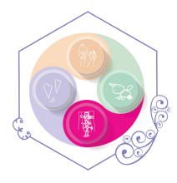 | 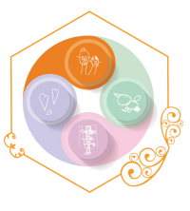 | 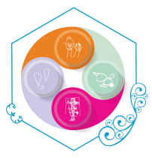 | 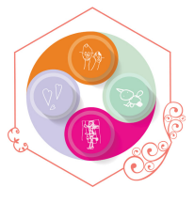 | 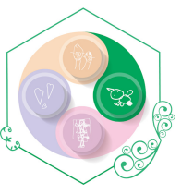 | 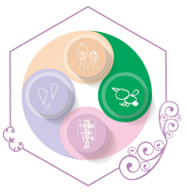
Collaboration | Communication | Critical Thinking & Problem-Solving | Innovation, Creativity & Entrepreneurship | Fostering and Teaching Self-Awareness and Self-Management | Sustainability and Global Citizenship
What You’ll Need

- Parks NB: Mount Carleton Provincial Park PPT | - Pencils  - Equipment (listed with each activity)

Instructions
Please note: The majority of this activity is intended to be provided in an outdoor learning environment, however, feel free to adapt and change to meet the needs of your learners and outdoor spaces.

1. The Great Outdoors & My Mental Health: Gather and discuss this question: “What is positive mental health?” Allow learners to suggest and share signs of what positive mental health might look like, sound like, feel like (positive self-talk, good attitude, kindness, confidence, clearness of mind, sound decisions, creative, etc.). Then, ask: “How does learning outdoors contribute to positive mental health?” Allow learners to provide examples, testimonials, and ideas of the correlation between positive mental health and outdoor learning.
*To review the benefits of outdoor play and mental health please see the PDF resource attached.*
2. Parks NB - Experience 10: Before beginning the activities, ask learners: “How many have been to a Parks NB site before? If yes, which one and what did you do there? Which is the closest Parks NB site to us?” Use slide 2 of the PowerPoint Presentation to refer to the NB map. Be sure to have learners dressed appropriately for the activities outlined below and have all materials prepared. There is no particular order of experiences - simply plan according to your preference. Here are how the experiences are organized:

Parks NB Experience: | Fall & Spring Activity | Winter Activity
2. Mount Carleton Provincial Park:  Mount Carleton | - Discussion  - Mountain Measuring  - Mount Carleton Obstacle Course | - Discussion  - Mountain Measuring  - Mount Carleton Winter Obstacle Course

Parks NB Experience #2: Mount Carleton
Park Highlight: Mount Carleton

Materials Needed: | - 1 Metre Stick  - Soccer Field (or large, inclined hill if possible)  - Chart Paper  - Marker  - Various gym equipment (see below)  - Smaller Items (various sizes of balls, pylons, frisbees, etc.) for packing into bookbags  - Hike Packing Cards – 1 per learner, see printable in Appendix  - Bookbag – 1 per learner

Instructions:

1. Mount Carleton Discussion: Discuss: “Mount Carleton is the highest peak in the Atlantic Provinces! Has anyone ever climbed it, or another mountain? Can you tell us about your experience. What is the difference between hiking on a trail in the woods and hiking a mountain?” Allow learners to discuss possibilities, as well as personal experiences with mountain climbing.

2. Mountain Measuring: Using a metre stick, demonstrate 1 m with it touching the ground and explain: “Mount Carleton is 824m in height, or 824 times this metre stick high. The mountain may be that tall, but would the trail up to it be straight up (vertical)? What other natural things might we have to navigate up to the top of Mount Carleton?” Allow learners to suggest: Tree roots, muddy conditions, Rocks/Boulders, Twists/Turns, Puddles, Lake/Rivers barriers to wade through, Natural Obstacles (fallen trees, windy conditions, bugs, beehives), etc.

3. Mount Carleton Obstacle Course: Using the chart paper, design your own Mount Carleton Obstacle Course experience. Measure a spot on either a soccer field or inclined hill – 10m to have one route up and one route returning to the start. Then, using a variety of gym equipment, have learners design obstacles and barriers. With each learner going through the obstacle course (up and back to start), each learner is traveling 20m. About 41 trips will need to be made to truly climb Mount Carleton. (Feel free to adjust the length of your course to meet your class’ needs). Gather learners and form a line at the start.

10 m
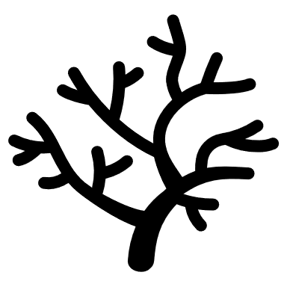

Learners packing bookbags using hike packing cards & waiting for turn




End
Start

Create a Packing Pile (a variety of small and medium items – balls, frisbees, random gym equipment) for students to pack in their bookbags, according to the card that they receive. Have the first 2 climbers, demonstrate packing their bookbags with the cards that you give them. Pass out a card for each learner. As soon as a learner finishes, they can return their packing items to the pile for someone else to use. Record your class time and REPEAT – to see if you can beat it OR challenge another class!

Winter Option: To build your Mount Carleton Obstacle Course, feel free to sculpt and build with the snow for natural obstacles, as well as natural materials or waterproof materials. Bookbags are optional, as outdoor clothing would create additional weight and challenge.

