Be a Nurse for a Day!
Exploring the Roles of Nurses and Addressing a Healthcare Challenge

Part 1: Understanding the Role of a Nurse
Choose ONE way to review the role and responsibilities of a nurse. Check your choice.
☐ Read a short description of a nurse’s daily tasks (Find in PDF of “What is a Registered Nurse”)
☐ Listen to the teacher explain the role of a nurse (Teacher can explain from PDF of “What is a Registered Nurse”)
☐ Look at visual diagrams of nurse responsibilities (See PDF attached of “Visual Diagrams of Nurses Responsibilities”)
☐ Watch a short video clip about nursing work (See video attached: How to become a Nurse with NBCC | Centre of Excellence for Health)
☐ Discuss with a partner and take shared notes
Write or draw ONE thing you learned about nurses roles and responsibilities:
____________________________________________________________
____________________________________________________________

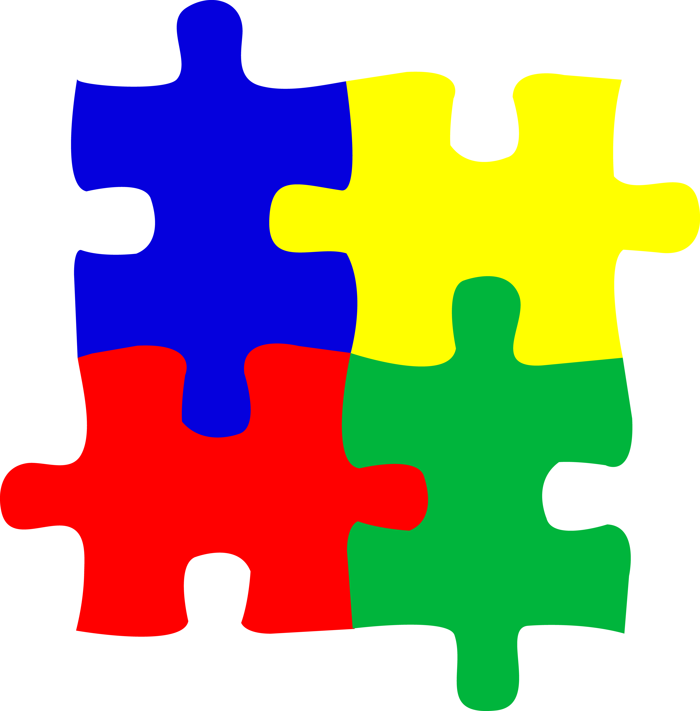
Part 2: Solve a Nursing Challenge
Think about one of the nursing scenarios from class.
Describe the situation (what happened?):
____________________________________________________________
____________________________________________________________
Why is this situation important or challenging?
____________________________________________________________
____________________________________________________________

How would you feel if you were the nurse? Why?
____________________________________________________________
____________________________________________________________

Part 3: Show What You Know
Choose ONE way to explain how the nurse should respond. Check your choice.
☐ Draw a diagram or flow chart
☐ Create a comic strip
☐ Record an oral explanation (teacher approval)
☐ Role-play the situation
Explain or create your response below (or attach your work):
____________________________________________________________
____________________________________________________________
____________________________________________________________


Part 4: Reflect on Your Learning
What new skill did you learn about nurses?
____________________________________________________________
Which part of the activity helped you learn the most?
____________________________________________________________
What strategy helped you understand the scenario?
____________________________________________________________
What additional information would you like to learn regarding healthcare careers?
____________________________________________________________

Student Self Assessment
Circle how you feel about your learning today.

I Understand What Nurses Do. | Not yet | A little | Mostly | Very well
I Explained My Thinking Clearly. | Not yet | A little | Mostly | Very well
I Stayed Engaged in the Activity. | Not yet | A little | Mostly | Very well
I used a Learning Strategy that Worked for me. | Not yet | A little | Mostly | Very well

