
Helping Us Find a Clearer Mind: The Power of Mindfulness

Overview
- Students will be introduced to the connection between breathing, the brain, the nervous system, and overall physical and mental well-being. They will explore the idea that breathing is unique: it is normally automatic, yet we can consciously change its rate, depth, and rhythm.
- Breathing is regulated primarily by respiratory centres in the brainstem, which continuously monitor signals related to oxygen and carbon dioxide levels.
- Students will investigate why breathing rates can change in response to exercise, stress, emotions, illness, sleep, posture, and other physiological demands.

NB Curricular Connections

Personal Wellness 6

Strand: Wellness – Big Idea: Healthy Lifestyle – Skill Descriptor: Examine personal health habits and their impact on the seven domains of wellness.
Strand: Mental Fitness – Big Idea: Positive Mental Health – Skill Descriptor: Describe strategies to support positive mental health.
Hook

The average person breathed 3.9 times/minute in 1930, 4.6 times/minute in 1940, and 5.9 times/minute in 1950 should not be presented as established scientific statistics without identifying and verifying the original study.

Today the average person breathes 12-20 breaths a minute.

What You’ll Need
- "Helping Us Find a Clearer Mind" PowerPoint *PDF attached*
- Instructions for the "Cloudy Water Experiment" *PDF attached*
- Teenager Body Scan Breathing Exercise "PDF attached"
- Reflection activity *Word Document Attached*

Instructions
- Read through "Helping Us Find a Clearer Mind" PowerPoint *PDF attached*

Slide 1 — What Is Mindfulness?
- Mindfulness = Notice. Pause. Choose.
- Mindfulness means paying attention to what is happening right now, on purpose, with curiosity, and without judging yourself.
- Studies show that we are not PRESENT 47% of the time – that is almost ½ of our life that we are not living!

In middle-school language:
- Mindfulness is noticing what is happening in your mind and body without immediately reacting to it.
Mindfulness is NOT:
- Emptying your mind
- Making thoughts disappear
- Being calm all the time
- Sitting perfectly still
3 Parts of Mindfulness
- INTENTION — I choose to pay attention.
- ATTENTION — I notice what is happening right now.
- ATTITUDE — I notice with curiosity instead of judging.
Mindfulness is a skill you can practice

Slide 2 — When Your Mind Gets Cloudy
Sometimes our minds get cloudy because of:
- Worry
- Anger
- Stress
- Sadness
- Frustration
- Overthinking
A cloudy mind might sound like:
- “I can't deal with this.”
- “Everyone is against me.”
- “I'm going to fail.”
Thoughts = Feelings = Reactions
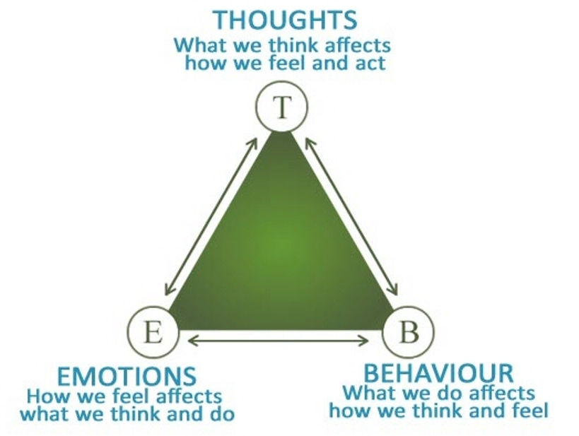

When our mind feels cloudy, it can be harder to:
- FOCUS
- LEARN
- LISTEN
- MAKE DECISIONS
Mindfulness helps us create a little space before we react.

Slide 3 — The Cloudy Water Experiment

Imagine your mind is like this Jar of water.


CLEAR WATER
- You can see clearly.
- You can focus on what is in front of you
- You see the “Toy”/Object behind the jar

CLOUDY WATER- Stir the Water
- This can represent stress in our bodies and minds
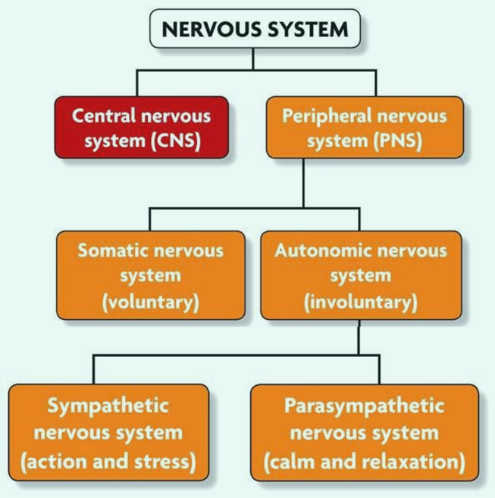

- Stress=strong emotions=lots of thoughts
- Can make things harder to see clearly.

STOP STIRRING - WATCH → WAIT → BREATHE
- You don't have to force the water to become clear.
- As the particles settle, the water gradually becomes clearer.
- Sometimes our minds are like the water.
- We don't have to fight every thought or feeling.
- We can pause and let ourselves settle.

Slide 4 — Mindfulness Is The Pause
NOTICE → PAUSE → BREATHE → CHOOSE
** This can be difficult for middle school students to practice and they struggle with identifying their emotions. **
Let’s Try It……..
1. NOTICE
“What am I thinking or feeling?”
2. PAUSE
Give yourself a moment.
3. BREATHE
Take a slow, steady breath.
4. CHOOSE
“What do I want to do next?”

Now Let’s Try Mindful Breathing
A 2 minute mindfulness practice can help introduce the NOTICE → PAUSE → BREATHE → CHOOSE concept to middle school students (Teenager body scan attached as PDF)
- Sit comfortably.
- Breathe slowly.
- Notice your breath.
- Notice your body.
- When your mind wanders, gently bring it back
- You don't have to stop thinking.
- Notice → Return → Notice → Return

Slide 5 — Your Turn: What Did You Notice?
Learner Reflection
What happened when the water became cloudy?
What happened when we stopped stirring?
Did you notice anything in your body?
When does your mind feel “cloudy”?
What helps you create a little clarity?

THE BIG IDEA
- We can't remove every stressful thing from our lives.
- But we can learn skills that help us respond to stressful moments.
- Mindfulness gives us a pause.
- NOTICE → PAUSE → BREATHE → CHOOSE
- You don't have to control every thought.
- You can choose what you do next.
The Research on Mindfulness in school-based contexts reveals the following list of core beliefs for educators and students:
- Increased ability to orient attention
- Increased working memory and planning and organization
- Increased self esteem
- Increased sense of calmness, relaxation, and self-acceptance
- Increased quality of sleep
- Decreased test anxiety
- Decreased ADHD behaviors- hyperactivity and impulsivity
- Decreased negative affect/emotions
- Fewer conduct and anger management problems
Mindfulness has been proven to be a successful intervention for calming the amygdala’s impulsive reaction to stressful or negative thoughts and experiences.
- Mindfulness enables us to access the pre-frontal cortex (rational, thinking mind).
- The pre-frontal cortex (PFC) also helps us to calm down by keeping the emotional brain in check.
- Mindfulness instils the practiced ability to stop, breathe (putting on the brakes of the amygdala) and think rationally.
- Since Mindfulness develops the prefrontal cortex, especially the left side where mood enhancement occurs, it makes sense that this practice also leads to more happiness.

- Complete "Cloudy Water Experiment"
* Word document attached*

3. Complete "Teenager Body Scan Breathing Experiment" *Word document attached*

Reflection Activity

*Word document attached*

UDL Supports

- Multiple means of engagement: Hands-on Cloudy Water Experiment, mindfulness/breathing activity.
- Multiple means of representation: PowerPoint presentation, diagrams, visuals, student-friendly definitions, cloudy water analogy.
- Multiple means of action and expression: Students complete an experiment, make observations, participate in a breathing exercise, answer reflection questions, and discuss what they noticed. The reflection component gives students an opportunity to communicate their understanding.

Global Competencies (optional)
Collaboration.pdf
Communication.pdf
CriticalThinking.pdf
Innovation.pdf
SelfAwareness.pdf



