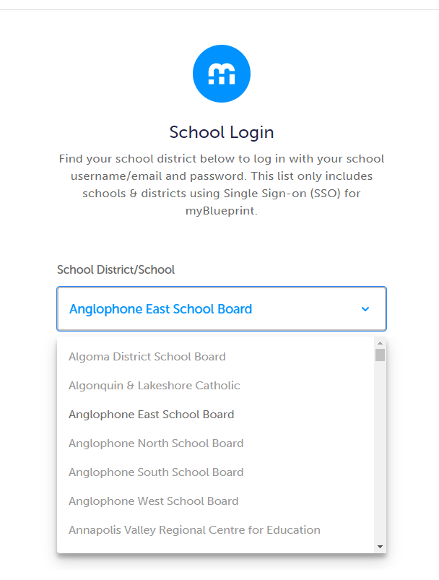
This guide outlines the steps teachers and students can take to begin documenting evidence of language learning using myBlueprint Digital Portfolios.

- LOG IN / SIGN UP *for both teacher/students*

- Visit www.myBlueprint.ca and click Log In
- Click School Account Log In
- Select your school district: Anglophone East, North, South, or West School Board
- Click Login with School Account
- Log in with your school district account credentials

- INSTRUCTIONS FOR TEACHERS

The first time you log in, you may be prompted to select your school and request approval from an administrator.

Once you’ve logged in and your account has been approved, create your class with the steps below:
  - Click Create Class
  - Enter a class name and click Create Class
  - Click Add Students
  - Find your students on the list and check the box to the left of their name - you can search by name and/or filter by grade
  - Once all students have been checked off, click the green Add Students button at the top right

- For video tutorials on creating a class, and other features of myBlueprint, see https://www.myblueprint.ca/support/videos
- To explore a demo student account, click the Student View button at the top right of your account
- As your students begin uploading content to their accounts, you’ll be able to view it in the Feed tab of your account
- If you want students to use the portfolios to reflect evidence of level based on the CEFR continuum, you will need to introduce your students to the levels/descriptors.

- RESOURCES
  - www.myBlueprint.ca/support:you
    - Class Pass App Guide
    - QR Code Login Guide

- INSTRUCTIONS FOR STUDENTS

- Log in to your myBlueprint account through a Web browser (Google Chrome recommended)
- To access portfolios:
  - Click Portfolios on the home screen
  - Click Add Portfolio to create a new portfolio, or click on a portfolio to open one that you’ve already created
- Click Add Box
- Click Add Media
  - Select Video or Audio to record - allow camera/microphone access when prompted
  - Click File to upload content already saved on your device
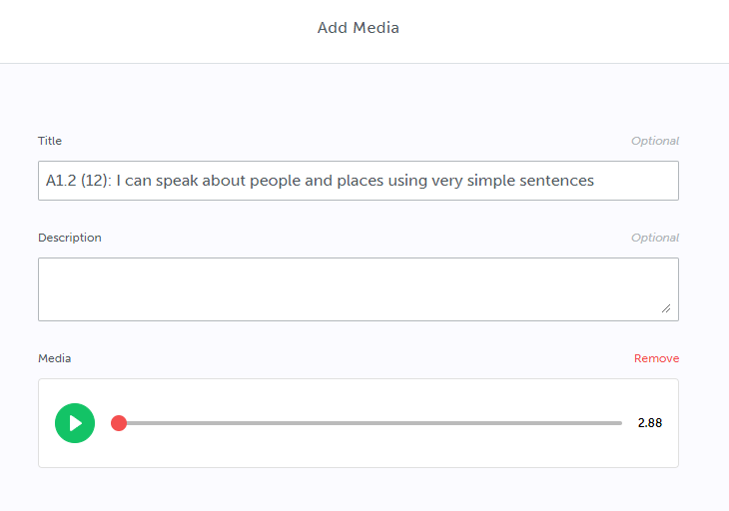
- If demonstrating your French proficiency, record an audio or video. Enter a title that includes the level number and proficiency statement that you are showing with this post, e.g. A1.2 (12): I can speak about people and places using very simple sentences.
- Click Post
- If you need to go back and edit a post, you can click the menu button at the top right of the post, then click Edit

- INSTRUCTIONS FOR STUDENTS - Class Pass app

  - Students can also use the Class Pass app for iOS / Android to more easily upload recordings from a tablet, particularly if it is being shared among multiple students in a class
  - In order to use the Class Pass app, teachers will first need to generate the QR code(s) for their class - see the QR Code Guide and Class Pass App guides above for more details
    - You can use the Class QR code to log in as the entire class, if you are using a shared device, then students can upload by simply selecting their name from the class list (posts require teacher approval by default)
    - You can also generate QR codes for individual students to simplify the login process if they are each using their own devices
  - When creating each post, simply ensure that the level number and proficiency statement are included in the post title

- Tips for Teachers

- Individual student QR codes can also be used to log in through a Web browser (e.g. Safari, Chrome) on a device with a camera, not just the Class Pass app.
- You can optionally create Class Activities for students to complete, and simplify the process of adding a particular proficiency to a portfolio
  - To learn more about creating and completing Class Activities, see this guide
  - Use the level and proficiency as the Activity name, and Media as the activity type: students’ portfolio boxes will automatically have the correct title populated by default
  - You can also add tags to a Class Activity to automatically have submissions tagged (see below)
  - This is not required, and you can have your students upload content in whatever way works best for your class, as long as the level number is included in the post title
- Tags:
  - Teachers and students can optionally use the Tags feature to identify levels or descriptors. Multiple proficiency descriptors could be also used for the same post - for example, if a student has recorded a video with evidence for more than one proficiency statement.
  - How teachers can add tags:
    - Open your Class
    - Click the Add/Edit link next to the Teacher Tags panel
    - Enter the tag(s) you want to create, including both the level and specific proficiency descriptor in brackets: e.g. A1.1 (1)
    - After each tag you create, click Create Tag or press Enter - you should see the tag in a blue box
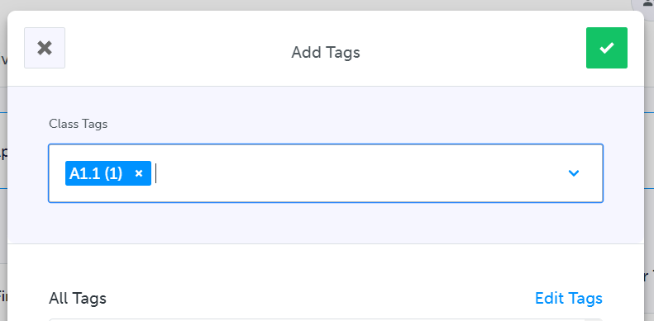
    - Click the green checkmark when all tags have been entered
    - You can then add the tags to posts in the Feed tab, or students in your class can select them when creating posts

- If you are assigning work through another LMS such as Microsoft Teams, you can use the direct login links below based on your school district. You can also bookmark the link for your district in your Web browser. These will bring staff & students directly into their myBlueprint accounts if they are already logged in with their school account.
  - https://core.myblueprint.ca/V5/login/SSO/anglophoneeast
  - https://core.myblueprint.ca/V5/login/SSO/anglophonewest
  - https://core.myblueprint.ca/V5/login/SSO/anglophonesouth
  - https://core.myblueprint.ca/V5/login/SSO/anglophonenorth
- For multiple teachers working with the same classes, only one teacher needs to create the class, then it can be shared with other teachers. Simply open the class and click the Share Class button near the top right.
  - Don’t see another teacher to add? You can send them an email invitation with the ‘Invite Colleague’ link.
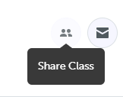
  - If they have a myBlueprint account already, check that you are both linked with the same school.

