TIANB’s Sustainability in Tourism Contest

# Students in 6-12, we want to hear from you!

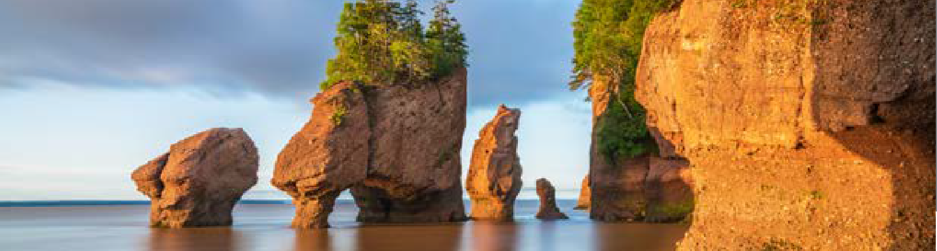

We want to know how operators and tourists are acting on and promoting sustainability.

You can help by participating in the Tourism Industry Association of New Brunswick’s (TIANB’s) Sustainability in Tourism Contest, in partnership with Education and Early Childhood Development (EECD). We want to learn from you. In a project of your choice, introduce us to an operator or a tourist destination in your community. Explore in your project how tourism in New Brunswick supports the Sustainable Development Goals and support NB to be a thriving destination. We look forward to and value your perspective.

# Prizes

Top groups in each category will win a cash prize.

# Guidelines

* This contest is open to all grade 6-12 students and/or classrooms in New Brunswick.
* Dialogue is to be in student’s language of instruction.
* Students will explore 1 question from the Question Bank and will identify a gap in their operator’s sustainability plans.
* Opens: October 15, 2025
* Entry deadline: April 17, 2026
* Additional important information about the contest can be found at [tianb.com](http://tianb.com/).

# Contact

EECD

* [Ginny.steeves@gnb.ca](mailto:Ginny.steeves@gnb.ca)

Districts:

* [ryan.price@nbed.nb.ca](mailto:ryan.price@nbed.nb.ca) (ASD-S)
* [peter.trusiak@nbed.nb.ca](mailto:peter.trusiak@nbed.nb.ca) (ASD-W)
* [kari.cheyne@nbed.nb.ca](mailto:kari.cheyne@nbed.nb.ca) (ASD-E)
* [jamie.otoole@nbed.nb.ca](mailto:jamie.otoole@nbed.nb.ca) (ASD-N)