Tiny Homes
An Exploratory Kit for Grades 3-5
In collaboration with Anglophone School District South
Overview
This kit features hands-on and inquiry-based learning activities exploring, creating, and constructing sustainable options for future home design. It is an invitation to experience a small snapshot of each of our 5 Centres of Excellence (Energy, Health, Entrepreneurship, Digital Innovation and Skilled Trades and Manufacturing). Happy Building!
NB Curricular Connections
3-5 Learning Areas
English Language Arts:
- Strand: Interactions - Big Idea: Expression – Skill Descriptor: Express and discuss thoughts, feelings, experiences, ideas, and opinions, and consider those of their peers.
- Strand: Reading - Big Idea: Reading Comprehension – Skill Descriptor: Connect and respond personally and critically to text.
Mathematics:
- Strand: Shape and Space - Big Idea: Measurement
Personal Wellness:
- Strand: Career Connected Learning - Big Idea: Experiencing Potential Career Pathways – Skill Descriptor: Engage in frequent and ongoing career connected experiential learning to learn about preferred career pathways and develop personal competencies.
Science:
- Strand: Learning and Living Sustainably - Big Idea: Responsible and Sustainable Application

What You’ll Need
- Pencils  - Design Template Sheet (included)  - Chart paper (1 sheet)  - PowerPoint – Tiny Homes (included)  - Read Aloud – If I Built a House  (By: Chris Van Dusen)  - Tiny Home Feedback Sheet (included) | - Maker Space materials: scissors, multi-colored cardstock, construction paper, tape, glue, aluminum foil, plastic wrap, white paper, etc.)  - Cm Grid Paper (printed on cardstock, 4-5 sheets per group)  - Lego Mini Figure Client Cards (included)

Instructions
- DISCUSSION: Gather your students together in a usual meeting place in your classroom. Using the PowerPoint, “Tiny Homes”, go to Slide 2 and ask: “What makes a house a home?” Begin to jot down ideas generated on chart paper or on a whiteboard. (Be sure to include the MUSTS – amenities, style, design features, space, etc.)

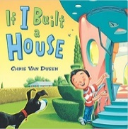
- READ ALOUD – If I Built a House (by: Chris Van Dusen)
Before reading, give students the chance to complete the sentence, “If I built a house….” to a partner nearby. Have 2-3 students share their completed sentences with the group.

- TINY HOMES: As amazing as Jack’s ideas for his dream house are in the book, the current trend in home design is actually - going small! Review and discuss slides 3, 4 and 5 of the PowerPoint with the students. At the bottom of Slide 5, when thinking about Tiny Homes Impact: Divide students into groups (by tables or location) and assign 1 of these topics to each group – environment, community & world, and economy - and then take the time for each group to share their ideas with the class. Continue to Slide 6 for how technology is playing a role in developing tiny homes, as well.
- CHALLENGE: Students will create a tiny home out of paper for a Lego Minifigure client. They must include:
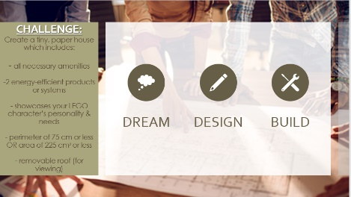
- all necessary amenities (bathroom, kitchen, bedroom, and a living space)
- 2 energy efficient products or systems (use provided checklist)
- showcase their LEGO character’s personality
- perimeter of 75 cm or less OR area of 225 cm² or less
- removable roof (for viewing inside)
Divide students into small groups. Together, read over the challenge on Slide 7, the design template page, and the energy-saving options sheet. Then, pass each group 1 Lego Minifigure client card to provide information about this character’s tiny home dreams. (Students do have the option of bringing one in from home and creating a biography card to use for this challenge, too!) Before students get their hands on the maker space materials, give them time to see what they can use, read over their Lego Minifigure client card, as well as sketch out their initial ideas using the Design Template. See past exemplars on Slide 8. Once they have a plan, let them build!

Examples from Mr.Reardon’s Grade 5 Class (from Townsview School in ASD-W, 2022):
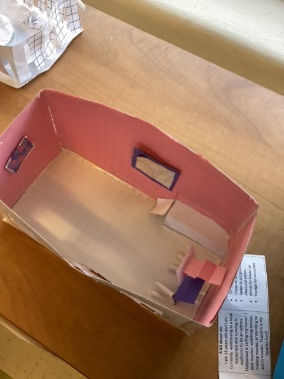
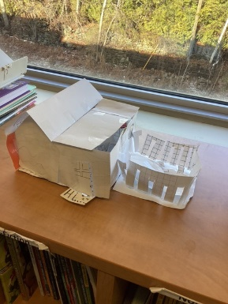
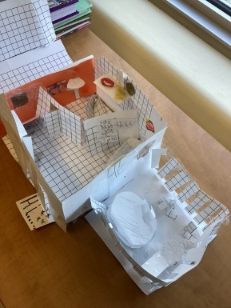
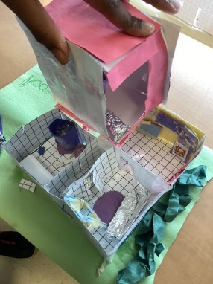

- PRESENTATIONS: House Viewing – Before presenting their houses in front of the class, give students the opportunity to do a viewing of each group’s house up close with a gallery walk. Students can cut out their Lego minifigure outline on the client card to ensure their client fits! Allow students to provide comments on the Tiny Home Feedback Sheet, set by each group’s house creation, as they circulate the room. Then, allow each group to present their house, their Lego Minifigure client, and the features that they included to the whole group.

- CAREER CONNECTIONS: Refer to Slide 8 and allow students to discuss the future job opportunities, in relation to Tiny Homes and our own Centres of Excellence. Can they think of more?
Centre of Excellence for Digital Innovation | 3D Printing Designers & Engineers
Centre of Excellence for Entrepreneurship | Marketing Consultants and Insurance Advisors
Centre of Excellence for Health | Health Care Workers for Tiny Homes Communities - Nurses & Physicians, Mental Health Counsellors, Fitness Advisors, Dieticians, Physiotherapists
Centre of Excellence for Energy | Tiny Home Energy Advisors
Centre of Excellence for Skilled Trades & Manufacturing | Carpenters, Plumbers, Electricians

- WRAP UP: Return to the original chart of “What makes a house a home?” and take the time to add to it or cross things off, as students reflect upon this learning opportunity. Allow students to discuss: “What are some challenges with tiny homes? How might a large family manage a tiny home? What are some advantages to tiny homes?”
Extension Ideas
- Use Lego bricks or a 3D Printer to create your Tiny Home!
- Visit a local Tiny Home manufacturer or Tiny Home Owner in your community
- Keep adding: Curate artwork for your Tiny Home using local artist stories and inspiration!
Reflection Activity
Please see the attached PDF for several choices on how you and your learners can reflect upon today’s activity.

Global Competencies
 | 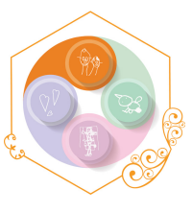 | 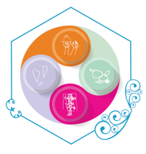 | 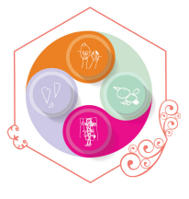 | 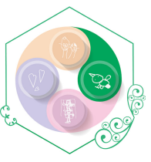 | 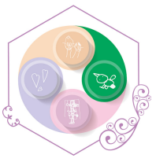
Collaboration | Communication | Critical Thinking & Problem-Solving | Innovation, Creativity & Entrepreneurship | Fostering and Teaching Self-Awareness and Self-Management | Sustainability and Global Citizenship

Acknowledgements
Wee Bitty Builders Inc - https://www.weebittybuilders.com/gallery/
Monika & Troy Hibbs, Tiny House Build from Start to Finish Time Lapse Video - https://youtu.be/xdyN6x6Bhyg
World Housing Facts – www.worldhousing.org
Canadian Home Data in relation to Climate Change - https://www.canada.ca/en/services/environment/weather/climatechange/climate-plan/climate-plan-overview/healthy-environment-healthy-economy/annex-homes-buildings.html
CTV News - https://atlantic.ctvnews.ca/fredericton-non-profit-completes-first-neighbourhood-block-of-tiny-homes-in-fight-against-homelessness-1.5918284
Cm grid paper - www.madisonpaper.com
NB Power - https://www.nbpower.com/en/save-energy/tips/
Habitat for Humanity Windsor-Essex 3D Construction Explained - https://www.youtube.com/watch?v=bgzwE0J3wcY
Lego Minifigure Outline - https://www.papertraildesign.com/wp-content/uploads/2018/03/Lego-minifigure-coloring-page.jpeg
Our Tiny Home Design

Group Members: __________________________________________________________________________
Our Tiny Home Design MUST include:

- all necessary amenities (bathroom, kitchen, bedroom, and a living space)

- at least 2 energy-efficient products or systems

- showcases our LEGO character’s personality and needs

- perimeter of 75 cm or less OR area of 225 cm² or less

- removable roof (for viewing inside)
Cool Features: _________________
______________________________
______________________________
______________________________
______________________________

We chose to include these Energy-Saving products/systems:
- ________________________________________________________
- ________________________________________________________
- ________________________________________________________
- ________________________________________________________

Our Tiny Home Feedback

Group Members: _____________________________________________________________________
Did this Tiny Home Design include?
- all necessary amenities (bathroom, kitchen, bedroom, and a living space)
- at least 2 energy-efficient products or systems
- showcases our LEGO character’s personality and needs
- perimeter of 75 cm or less OR area of 225 cm² or less
- removable roof (for viewing inside)
Comments:
Energy-Efficient Options

(Please choose AT LEAST 2 to add to your design)
Heating Pumps  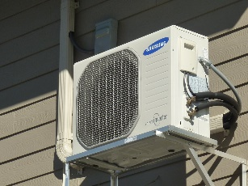  Heat pumps are a great way to heat your home and provide air conditioning in the summer months all while using less energy than most heating options.  This Photo by Unknown Author is licensed under CC BY-NC | 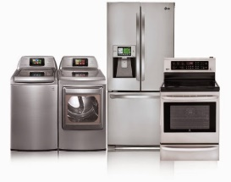  ENERGY STAR® Certified Appliances  These appliances look the same as others but use a lot less energy to run. | 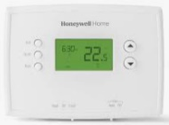  Programmable Thermostats  Install a programmable thermostat to help set your heat a little lower while sleeping or when you are away. For every 3°C lower, you could save 6% on your electric heating costs (an average of $68/yr) | ENERGY STAR® Qualified Windows  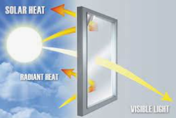  (and lots of them)  Installing these windows, allows the natural warmth and heat from the sun help heat your home. They also have a special coating to protect against UV rays.
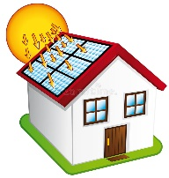  Solar Panels  Using the sun’s power, solar panels on top of you tiny home’s roof, can generate enough electricity for your whole home. | Curtains and Blinds  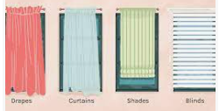  Having curtains and blinds gives the homeowner the option of to keep windows covered during the hot, summer months. This is energy-saving, especially when using air conditioning. | 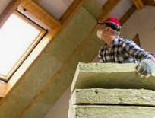  Closed Cell Spray-Foam Insulation  This is the most energy-efficient insulation that goes between your walls. It can reach more thickness than any other product. The more insulation, the less heating/cooling your house needs. | 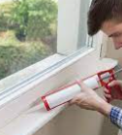  Weather Stripping and Caulking  This extra protection seals any potential gaps or cracks around windows and window trim. Caulking can also be added to spaces around water pipes and vents.
Shower With Energy Efficient Showerhead  Showers use less hot water than baths. A water-efficient showerhead uses about 50% less water and saves an average of $25/yr. | An Insulated Tank Toilet with Low Flush  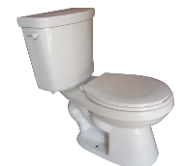  These toilets use a lot less water when flushed and can reduce the “sweating” on the toilet tank that leads to extra moisture and mould. | LED Lightbulbs  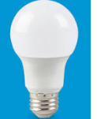  Reduce energy by installing LED bulbs for all lighting fixtures, as they use 75% less energy and last 25X longer than regular incandescent bulbs. | 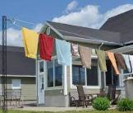  Clothesline  Use a clothesline to dry clothes whenever possible to save energy costs related to the dryer.

Lego Minifigure Client Cards
1 per group is needed
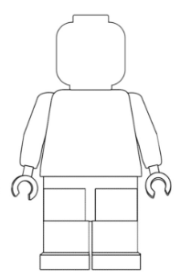  Maxwell Wellmax | A bit about me:  I love the outdoors! I am 41 years old and I have 1 dog (poodle named Eldoop!) I work as an accountant in a small office space, so in my free time I enjoy biking, hiking, and canoeing. I also enjoy campfires and star gazing. | Tiny Home Wishes:  - A dog bed and dog door for Eldoop  - Reflects my love of the outdoors  - Have lots of windows  - A Tiny Home that helps the great outdoors that I love
Susan Starfield | A bit about me:  I am 26 years old and I am currently waitressing at a local restaurant and running to auditions to be an actress. Hollywood is calling my name! I love movies- watching movies, making movies, pretending to act in movies. Popcorn is my favorite food! | Tiny Home Wishes:  - TV  - Cheap as possible  - Space to act/practice plays and scripts  - Mirror for Make-up  - Storage for costumes
Peter Bucketson | A bit about me:  I am 33 years old and I am a PowerLine Technician. I also am an avid basketball fan (Go Raptors!) and I help coach a local Mini Boys Basketball team. I like to keep in shape with early morning jogs and I have 3 Siamese cats (Carly, Marly, and Knarly). | Tiny Home Wishes:  - Cat tree for my cats  - Energy efficient heating  - Small basketball hoop inside for shooting  - TV for Raptors’ games  - Washer & Dryer for sweaty clothes
Claudette Painterson | A bit about me:  I am 67 years old and I am a retired teacher. Now, I spend my days creating water colour paintings as an artist. I love the ocean! It is the inspiration behind my artwork. I have 3 daughters, 12 grandkids, and 4 great-grandchildren who like to visit me often. | Tiny Home Wishes:  - Near the beach  - Outdoor Porch  - Storage for art supplies  - Colorful inside  - Lots of windows for viewing the sea
Lego Minifigure Client Cards
1 per group is needed
Ricky Rocksman | A bit about me:  ROCK ON! I have 3 electric guitars that I like to play LOUD! I am 42 years old and the lead guitarist in a rock band called, “ROCK, PAPER, SCISSORS, PEBBLE”. My music career means that I stay up late and sleep in until 2pm until I rock some more! I also love pizza, leather, and riding my electric scooter. | Tiny Home Wishes:  - Curtains for keeping the light out while I sleep  - Electrical Outlets easy to reach for my guitar  - Space to ROCK!
Camilla Watergate | A bit about me:  I am descended from British royalty and I am the president of a very established sailship building company. I have fancy taste, drink tea at precisely 2pm everyday, and I enjoy tidy plants. I like everything to be in order and I despise dirt. | Tiny Home Wishes:  - Elegant design  - Spot for Tea Time  - Indoor Plants  - Neutral colors with hints of gold, silver, and bronze
Steward Stichitup | A bit about me:  I am a 34 year old heart surgeon that loves sweater vests, scuba diving, and traveling around the world. When I’m not stitching up hearts, I also love to cross stitch wall hangings that reflect places I have been (Rome, Italy, Australia, and Brazil). I also speak 8 languages. | Tiny Home Wishes:  - World-like feel  - Space for luggage and scuba gear  - Washer & Dryer for washing out scrubs  - Solar Panels
Guy Gamerton | A bit about me:  I am a 38 year old video game developper who works from home. I love video games (PS4, X-box, Nintendo). I also love reading, spending time outside, and baking different types of breads. I also have a pet parrot, named Repeat who sits on my shoulder as I work. | Tiny Home Wishes:  - Porch for outdoor reading  - Space for Repeat’s bird cage  - Workspace with computer and video game consoles  - Least energy costs per month
Lego Minifigure Client Cards
Students can bring in their own Lego MiniFigure from home and create a unique client card for their Tiny Home Project (1 per group is needed)
______________________ | A bit about me:  __________________________  __________________________  __________________________  __________________________  __________________________  __________________________  __________________________  __________________________ | Tiny Home Wishes:  - ___________________  - _________________  - _________________  - _________________  - _________________  - _________________
______________________ | A bit about me:  __________________________  __________________________  __________________________  __________________________  __________________________  __________________________  __________________________  __________________________ | Tiny Home Wishes:  - ___________________  - _________________  - _________________  - _________________  - _________________  - _________________
______________________ | A bit about me:  __________________________  __________________________  __________________________  __________________________  __________________________  __________________________  __________________________  __________________________ | Tiny Home Wishes:  - ___________________  - _________________  - _________________  - _________________  - _________________  - _________________
_____________________ | A bit about me:  __________________________  __________________________  __________________________  __________________________  __________________________  __________________________  __________________________  __________________________ | Tiny Home Wishes:  - ___________________  - _________________  - _________________  - _________________  - _________________  - _________________

