Health and Safety at Work: Your Rights

Student Worksheet

**RIGHT TO KNOW**

**Activity 1: Hazard Identification**

Can you find four hazards in this workplace?

Complete the hazard assessment table found below the picture.

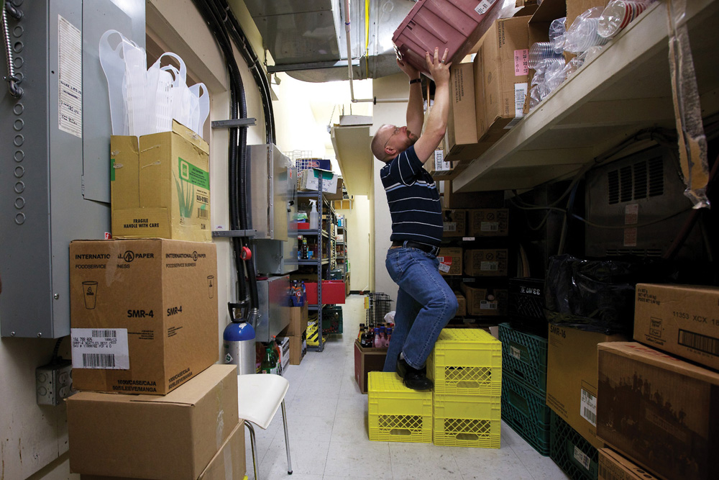

**© WorkSafeBC (Workers’ Compensation Board), used with permission**

Hazard assessment table

|  |  |  |
| --- | --- | --- |
| Hazard | What could happen? | How could it be corrected? |
|  |  |  |
|  |  |  |
|  |  |  |
|  |  |  |

**RIGHT TO PARTICIPATE**

**Activity 2: Participation Practice**

Role play a conversation between a worker and a supervisor, where the worker is participating in their workplace safety.

|  |  |
| --- | --- |
| Worker | Supervisor |
|  |  |

**RIGHT TO REFUSE**

**Activity 3: Saying “No”**

Design a poster to help workers know when to exercise their right to refuse.

Make your poster bright and bold and eye-catching!

**For more information on workplace safety:**

Visit www.worksafenb.ca

Or contact Jessica MacDonald, Health and Safety Consultant at WorkSafeNB

Email: [jessica.macdonald@ws-ts.nb.ca](mailto:jessica.macdonald@ws-ts.nb.ca)